**Rotation Device**

**Preparation Guide**

February 2017



<https://github.com/Colorado-Space-Grant-Consortium/Robotics_Challenge/blob/2016_master/Beacon_System/Beacon%20System%20Guide%202017.pdf>

**Parts Needed**

All links to solidworks files for parts that must be laser cut/ 3-D Printed can be found on github in the Beacon CAD folder (link below).

[**https://github.com/Colorado-Space-Grant-Consortium/Robotics_Challenge/tree/2016_master/Beacon_System/Beacon%20CAD**](https://github.com/Colorado-Space-Grant-Consortium/Robotics_Challenge/tree/2016_master/Beacon_System/Beacon%20CAD)

Rotation Plate

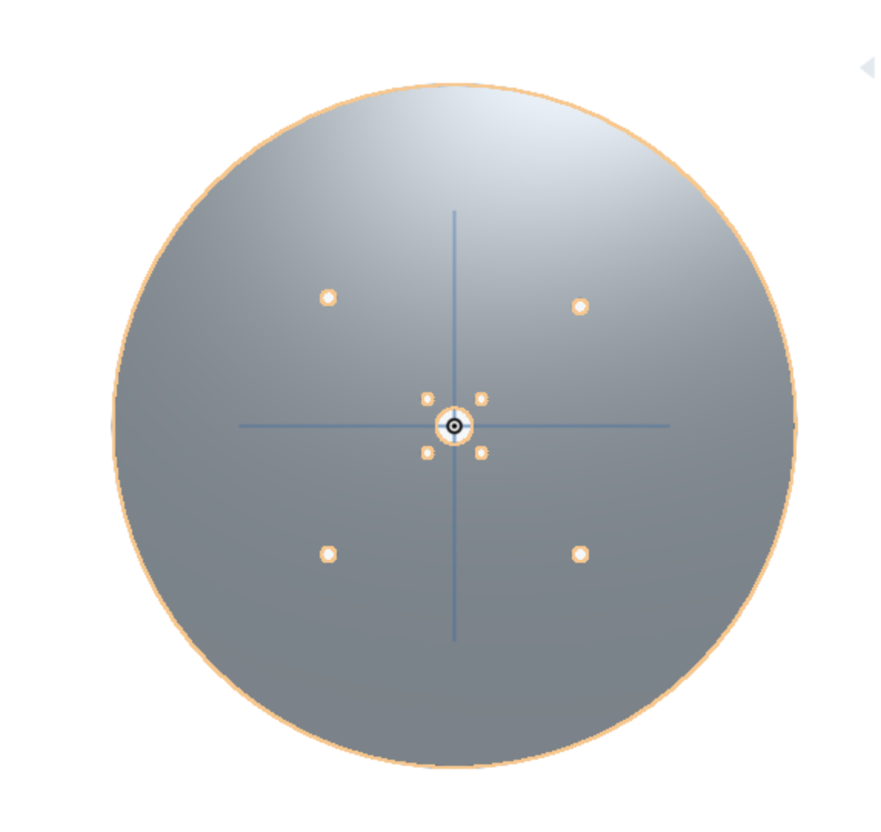

Acrylic (Laser cut) ¼ in-½ in thickness recommended

<https://github.com/Colorado-Space-Grant-Consortium/Robotics_Challenge/blob/2016_master/Beacon_System/Beacon%20CAD/Beacon%20Top%20(1).sldprt>

Base Top

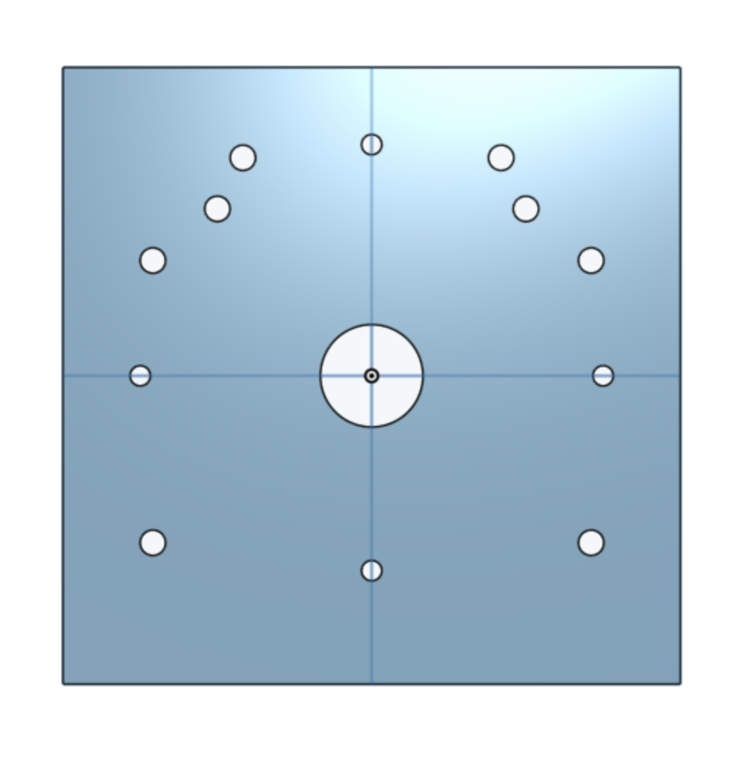

Acrylic (Laser cut) ¼ in recommended

<https://github.com/Colorado-Space-Grant-Consortium/Robotics_Challenge/blob/2016_master/Beacon_System/Beacon%20CAD/Beacon%20Base%20Top.sldprt>

Base Left Side

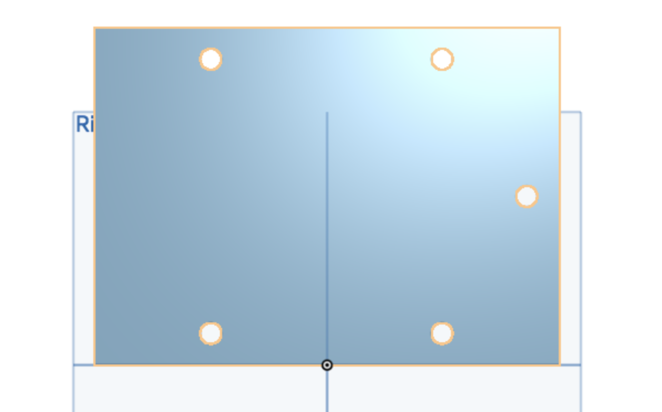

Acrylic (Laser cut) ¼ in recommended

<https://github.com/Colorado-Space-Grant-Consortium/Robotics_Challenge/blob/2016_master/Beacon_System/Beacon%20CAD/Beacon%20Base%20Left%20Side.sldprt>

Base Right Side

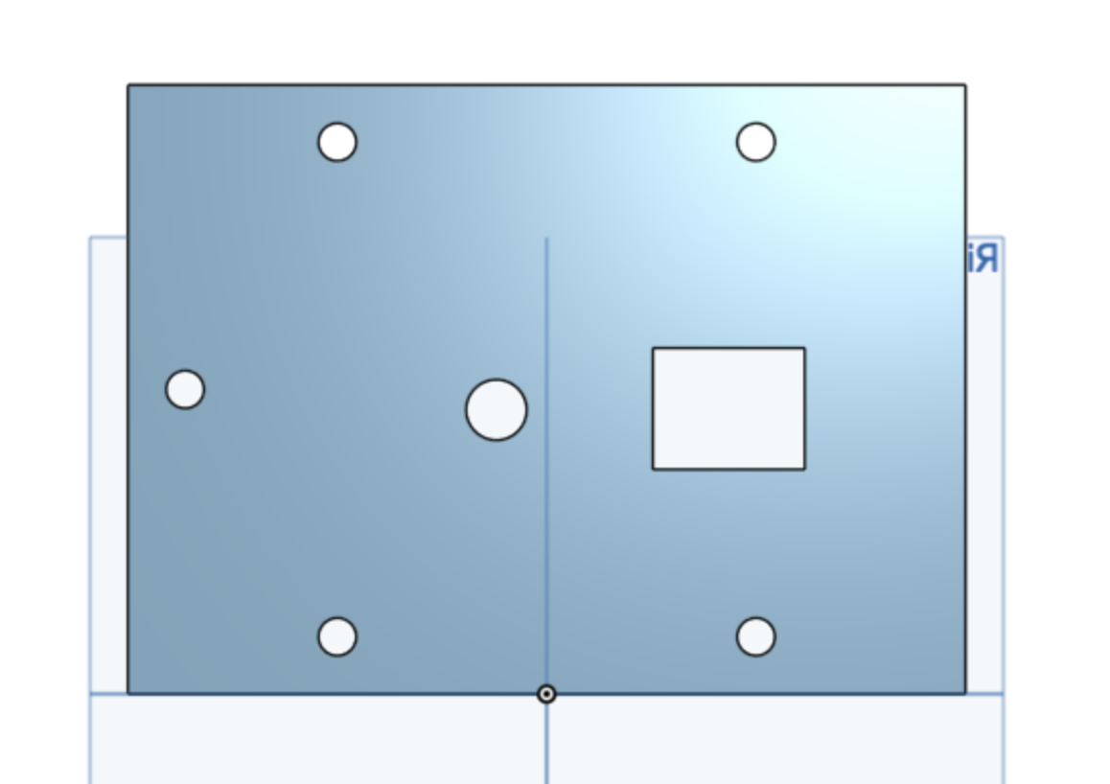

Acrylic (Laser cut) ¼ in recommended

Notes:

* Change dimensions of smaller rectangle based on size of button/switch

<https://github.com/Colorado-Space-Grant-Consortium/Robotics_Challenge/blob/2016_master/Beacon_System/Beacon%20CAD/Beacon%20Base%20Right%20Side.sldprt>

Base Back

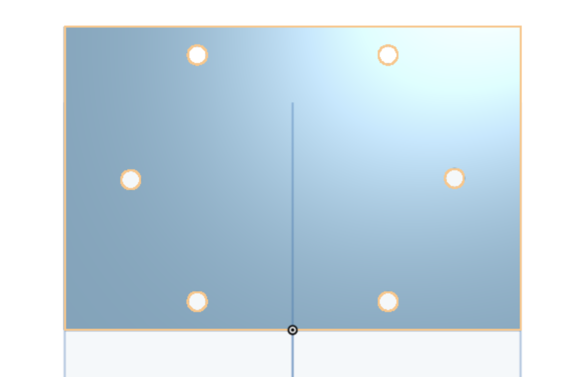

Acrylic (Laser cut) ¼ in recommended

<https://github.com/Colorado-Space-Grant-Consortium/Robotics_Challenge/blob/2016_master/Beacon_System/Beacon%20CAD/Beacon%20Base%20Back.sldprt>

Base Bottom

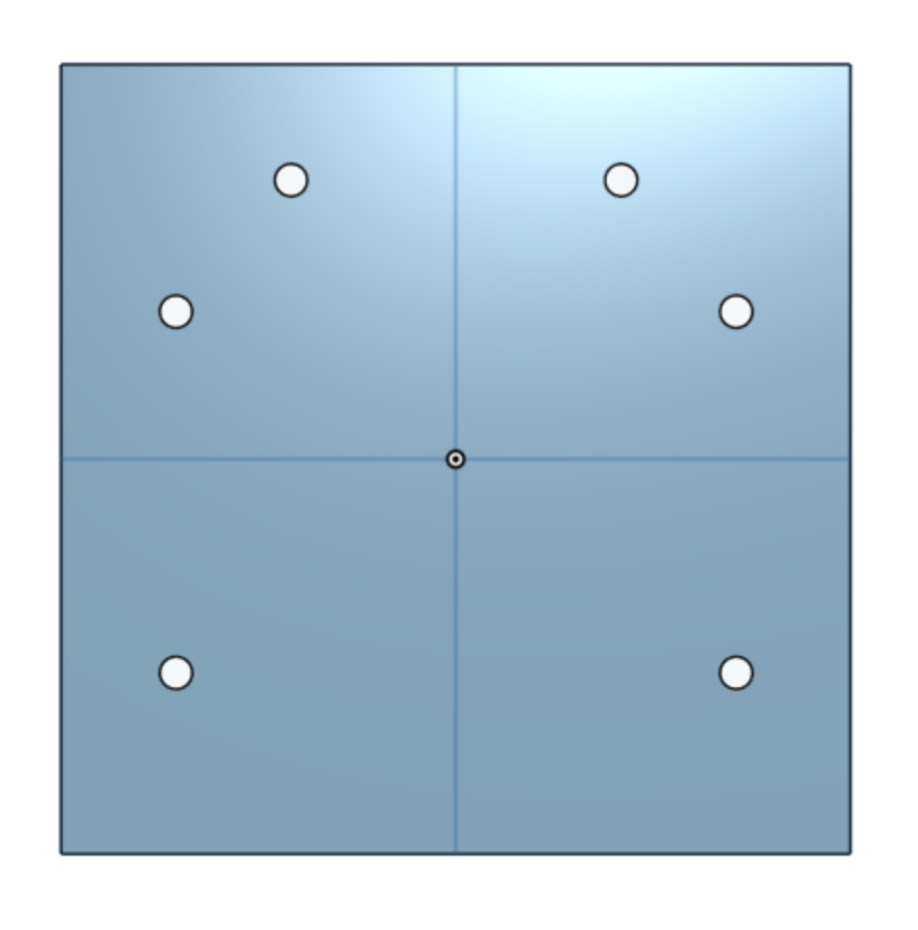

Acrylic (Laser cut) ¼ in recommended

<https://github.com/Colorado-Space-Grant-Consortium/Robotics_Challenge/blob/2016_master/Beacon_System/Beacon%20CAD/Beacon%20Base%20Back.sldprt>

Beacon Motor Attachment

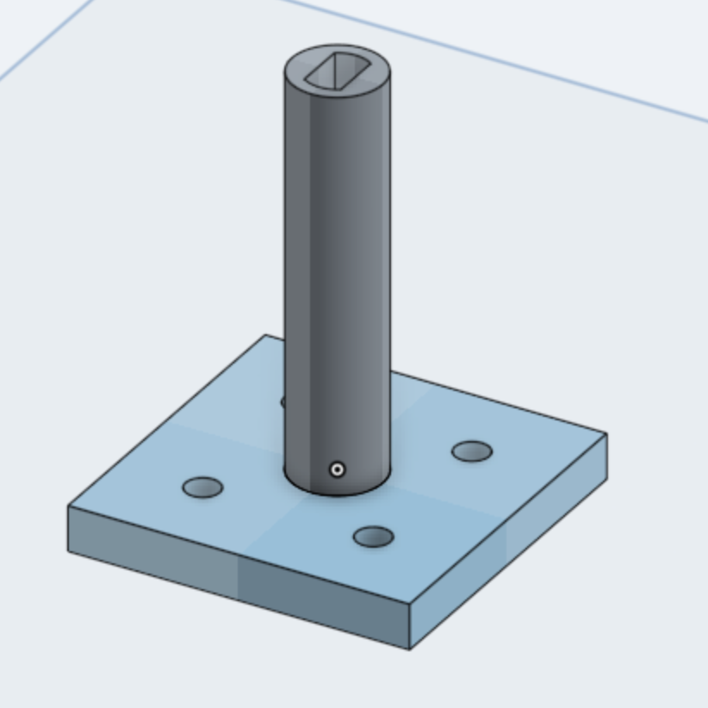

3D Printed (PLA recommended)

<https://github.com/Colorado-Space-Grant-Consortium/Robotics_Challenge/blob/2016_master/Beacon_System/Beacon%20CAD/Beacon%20Motor%203D%20attachment.sldprt>

Motor Attachment Plate

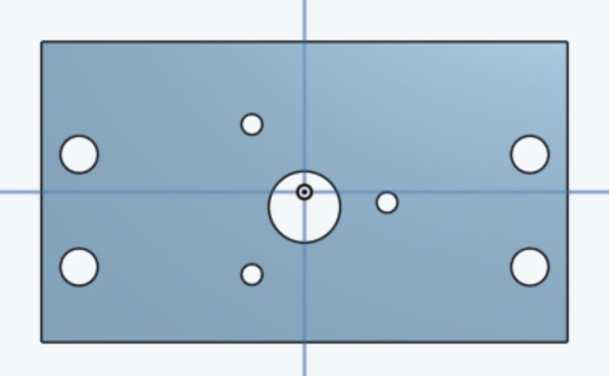

<https://github.com/Colorado-Space-Grant-Consortium/Robotics_Challenge/blob/2016_master/Beacon_System/Beacon%20CAD/Beacon%20Motor%20Attachment.sldprt>

Bearing

### Unlubricated Turntable 4" Square galvanized steel

<https://www.mcmaster.com/#6031k17/=1anp8xk>

### Brackets

### 14 - Everbilt 3/4 in. Zinc Plated Corner Braces

### [https://www.homedepot.com/p/Everbilt-3-4-in-Zinc-Plated-Corner-Braces-4-Pack-13542/20290157](https://www.homedepot.com/p/Everbilt-3-4-in-Zinc-Plated-Corner-Braces-4-Pack-13542/202950157)

2 - Everbilt 1 in. Zinc-Plated Corner Brace Value Pack (gorund down to .8 on oneside) <https://www.homedepot.com/p/Everbilt-1-in-Zinc-Plated-Corner-Brace-Value-Pack-20-Pack-18589/202034303>

2 - Everbilt 1-1/2 in. Zinc-Plated Corner Brace

<https://www.homedepot.com/p/Everbilt-1-1-2-in-Zinc-Plated-Corner-Brace-4-Pack-15304/202033892>

Motor

# Zhengk 12V DC 300 RPM 37GB High Torque Gearbox Electric Motor 37mm Diameter Silver - <https://www.aliexpress.com/item/zhengk-12V-DC-300-RPM-37GB-High-Torque-Gearbox-Electric-Motor-37mm-Diameter-Silver/32753142332.html?src=google&albslr=228989992&isdl=y&aff_short_key=UneMJZVf&source=%7Bifdyn:dyn%7D%7Bifpla:pla%7D%7Bifdbm:DBM&albch=DID%7D&src=google&albch=shopping&acnt=708-803-3821&isdl=y&albcp=653153647&albag=34728528644&slnk=&trgt=61865531738&plac=&crea=en32753142332&netw=g&device=c&mtctp=&gclid=EAIaIQobChMI7ovxx7mZ2QIVHJ7ACh0mrAFHEAQYAiABEgKd4PD_BwE>

Batteries

4 1.5V AA batteries

Battery Pack

6V Battery Pack

Button/Switch

<https://www.e-switch.com/product-catalog/illuminated/product-lines/pb1973-series-snap-in-illuminated-panel-mount-pushbutton#.WjB3hLaZOu4>

Note - Any button would work. Make sure the dimensions match the corresponding hole on the Base Right Side

Resistors/Potentiometer

For this beacon, approximately 6 Volts is required to power the motor. This will vary for each system based upon the load on the motor. This can be achieved through varying number of batteries, adding resistors, or a potentiometer. The most straightforward way is to limit number of batteries. An optional hole has been included in the right side of the beacon to accommodate a potentiometer.

Tripod

<https://www.amazon.com/AmazonBasics-50-Inch-Lightweight-Tripod-Bag/dp/B00XI87KV8/ref=sr_1_2_sspa?ie=UTF8&qid=1513126462&sr=8-2-spons&keywords=tripod&psc=1>

Screws:

38: 8-32 x 1/2in

4: 6-32 x 1.5in

4: 6-32 x 5/8in

4: 4-40 x 0.5in

4: 6-32 x 1/2in

1: 10-32 x 3/4in

Nuts:

36: 8-32 nuts

4: 6-32 nuts

1: 10-32 locking nut

8: 8-32 locking nut

4: 4-40 locking nuts

Washers:

1: 10-32-1.25 in washer

1: 10-32-0.5 in diameter washer

Loctite Blue:

It is recommended to secure all screws with a dab of loctite blue on the threads prior to operation to prevent the screws from backing out due to vibration. Assemble the beacon **without glue first** to ensure all parts fit properly. This loctite is removable should you make a mistake, but will require a significant amount of heat and effort to remove.

[Loctite Blue - Amazon](https://www.amazon.com/Loctite-Heavy-Duty-Threadlocker-Single/dp/B000I1RSNS/ref=pd_lpo_vtph_263_bs_lp_t_1?_encoding=UTF8&psc=1&refRID=B42VDA4MVEJMFA99MRR8)

**Building Instructions**

**Circuit**

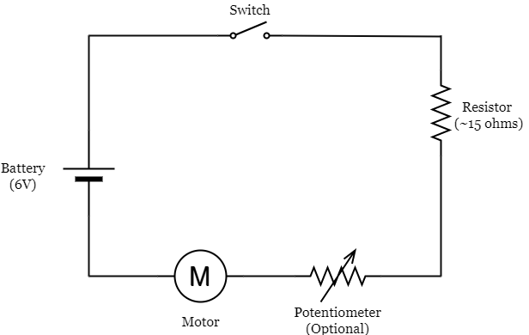

1. Solder Motor, Button, Battery pack, and resistors in series. About 6 Volts must be flowing through the motor for proper speed (though this will vary slightly)
   1. Use heat shrink tubing to protect all solder joints
   2. Stranded wire is recommended (as opposed to solid wire) as it is more flexible.
   3. If resistors are getting warm, too much current is flowing through them. Remove resistors, and decrease voltage through the motor by removing batteries instead

**Rotation Plate**

1. Insert motor into 3-D printed Beacon Motor Attachment to ensure fit. If the fit is two tight, carefully shave down some of the plastic on the interior with sandpaper or a dremel.
2. Attach the Beacon Motor Attachment to the Rotation Plate using the 4-40 x 0.5in screws and 4-40 locking nuts
   1. Ensure the locking nuts are secure on the screws, but that the part is loose enough to allow for a little bit of movement
   2. Make sure the Beacon Motor Attachment is in the direct center of the hole in the rotation plate
   3. The black electrical tape is to aid in measuring the rotation rate later

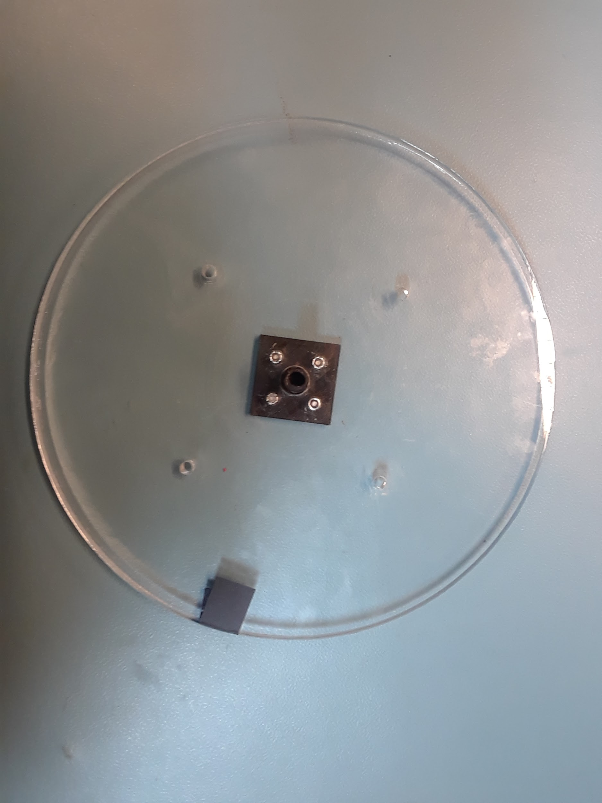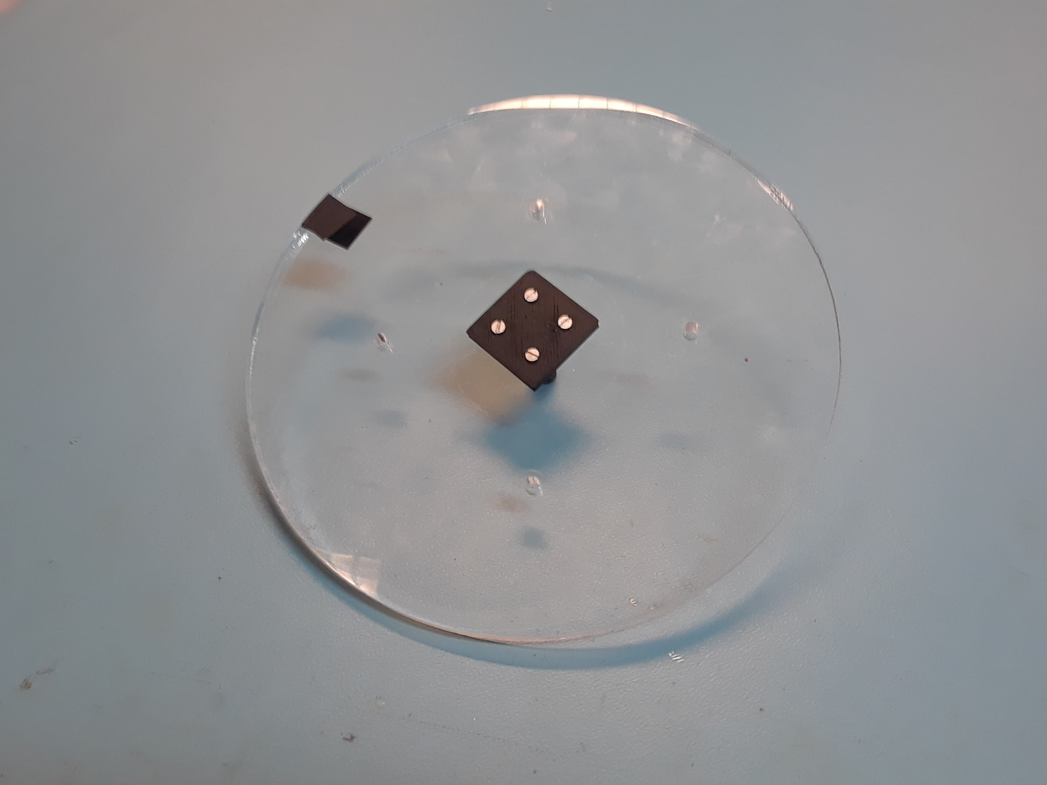

**Motor Mount Plate**

1. Grind down 2 Everbilt 1.5 in. Zinc-Plated Corner Braces to .8in on side, and grind down 2 Everbilt 1 in. Zinc-Plated Corner Braces to .8in on side

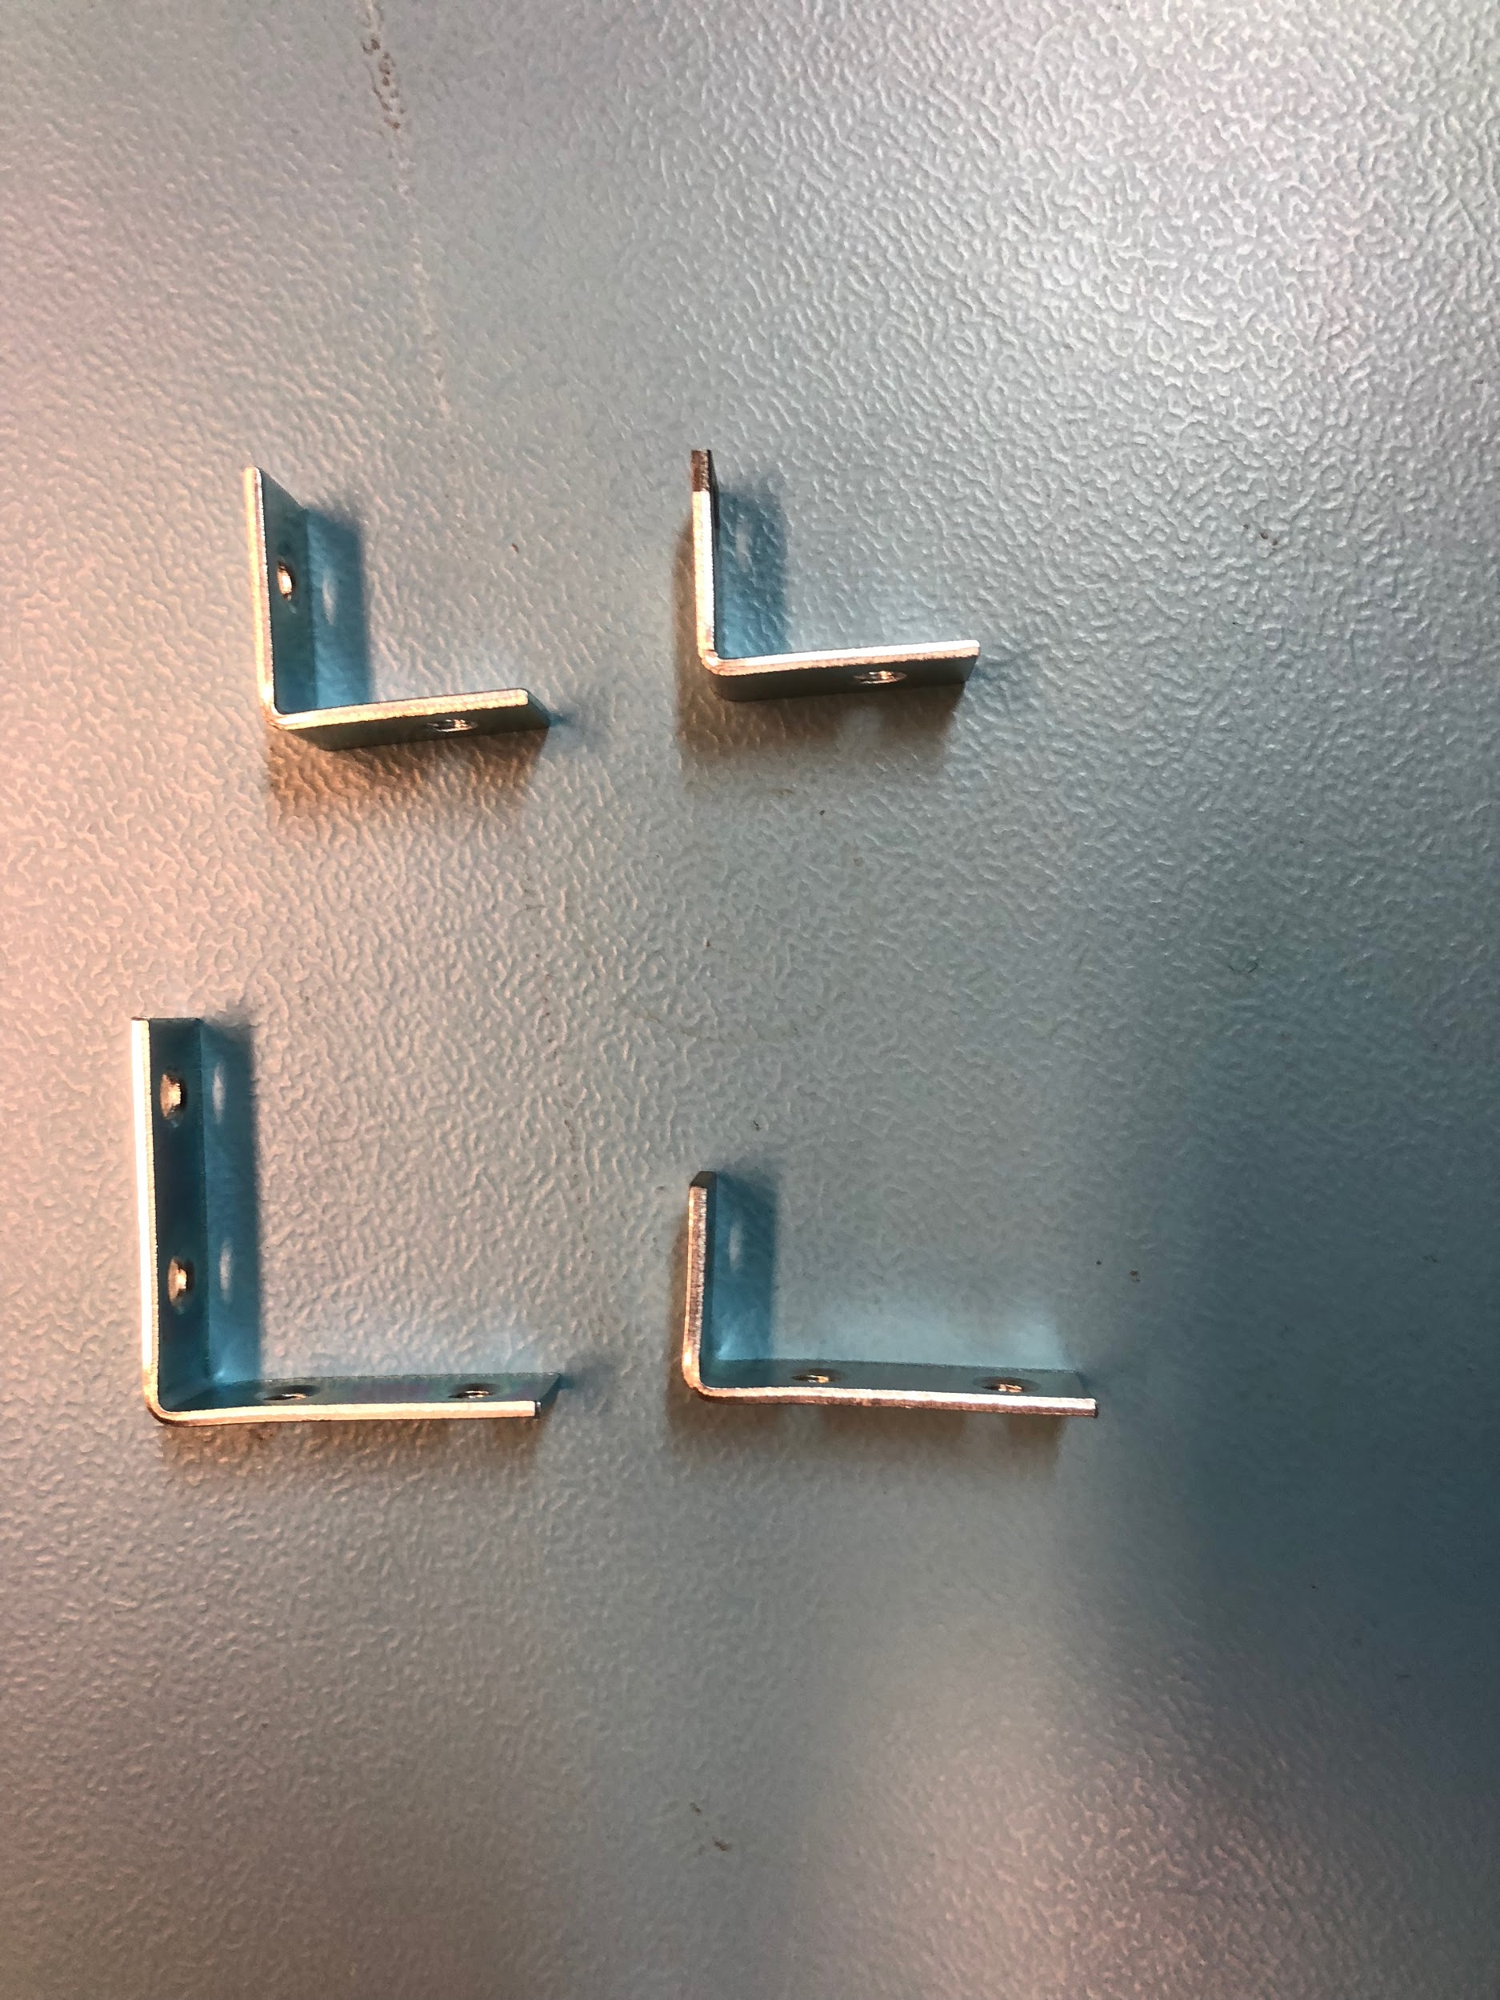

1. Repeat twice - Take the short side of the 1.5 in. Zinc-Plated Corner Brace (the side the is now .8in long) and attach it to the long side, to make an ‘s’ shape using a 8-32 x 3/8in screw and a 8-32 nut

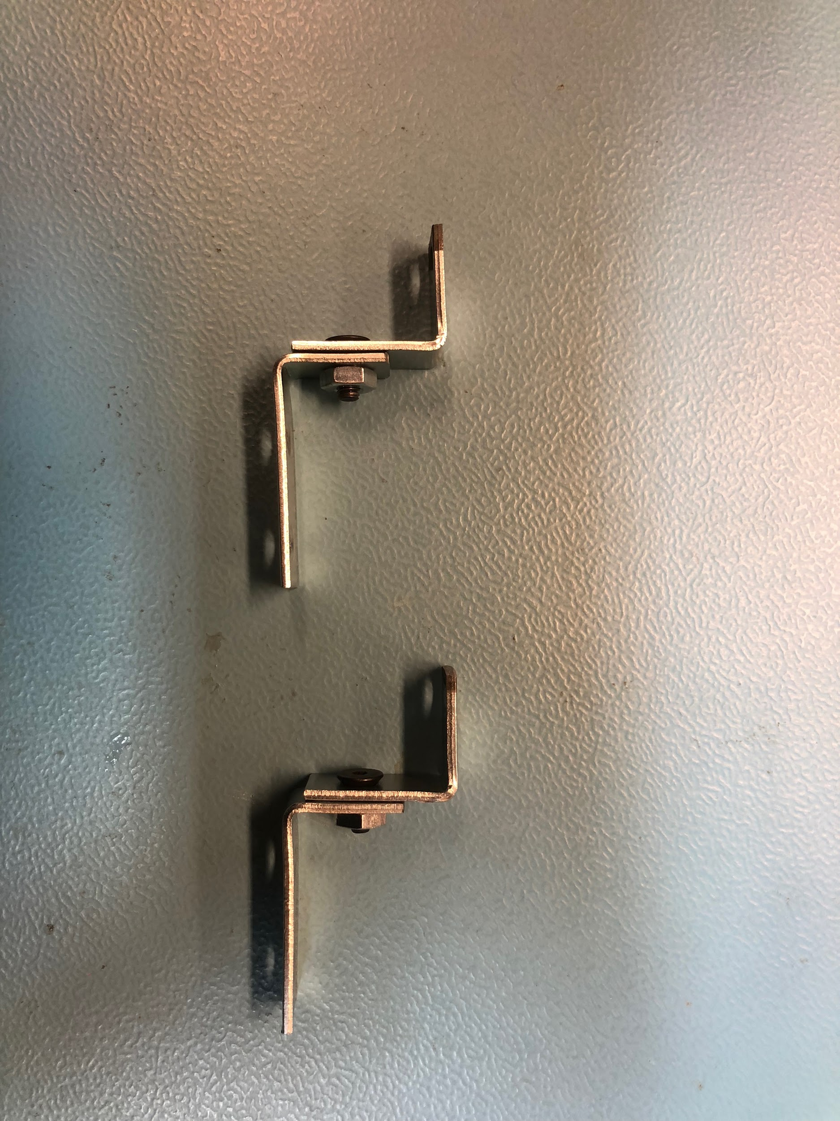

1. Use four 8-32 x 3/8in screws with 8-32 nuts to attach the brackets to the Motor Mounting Plate

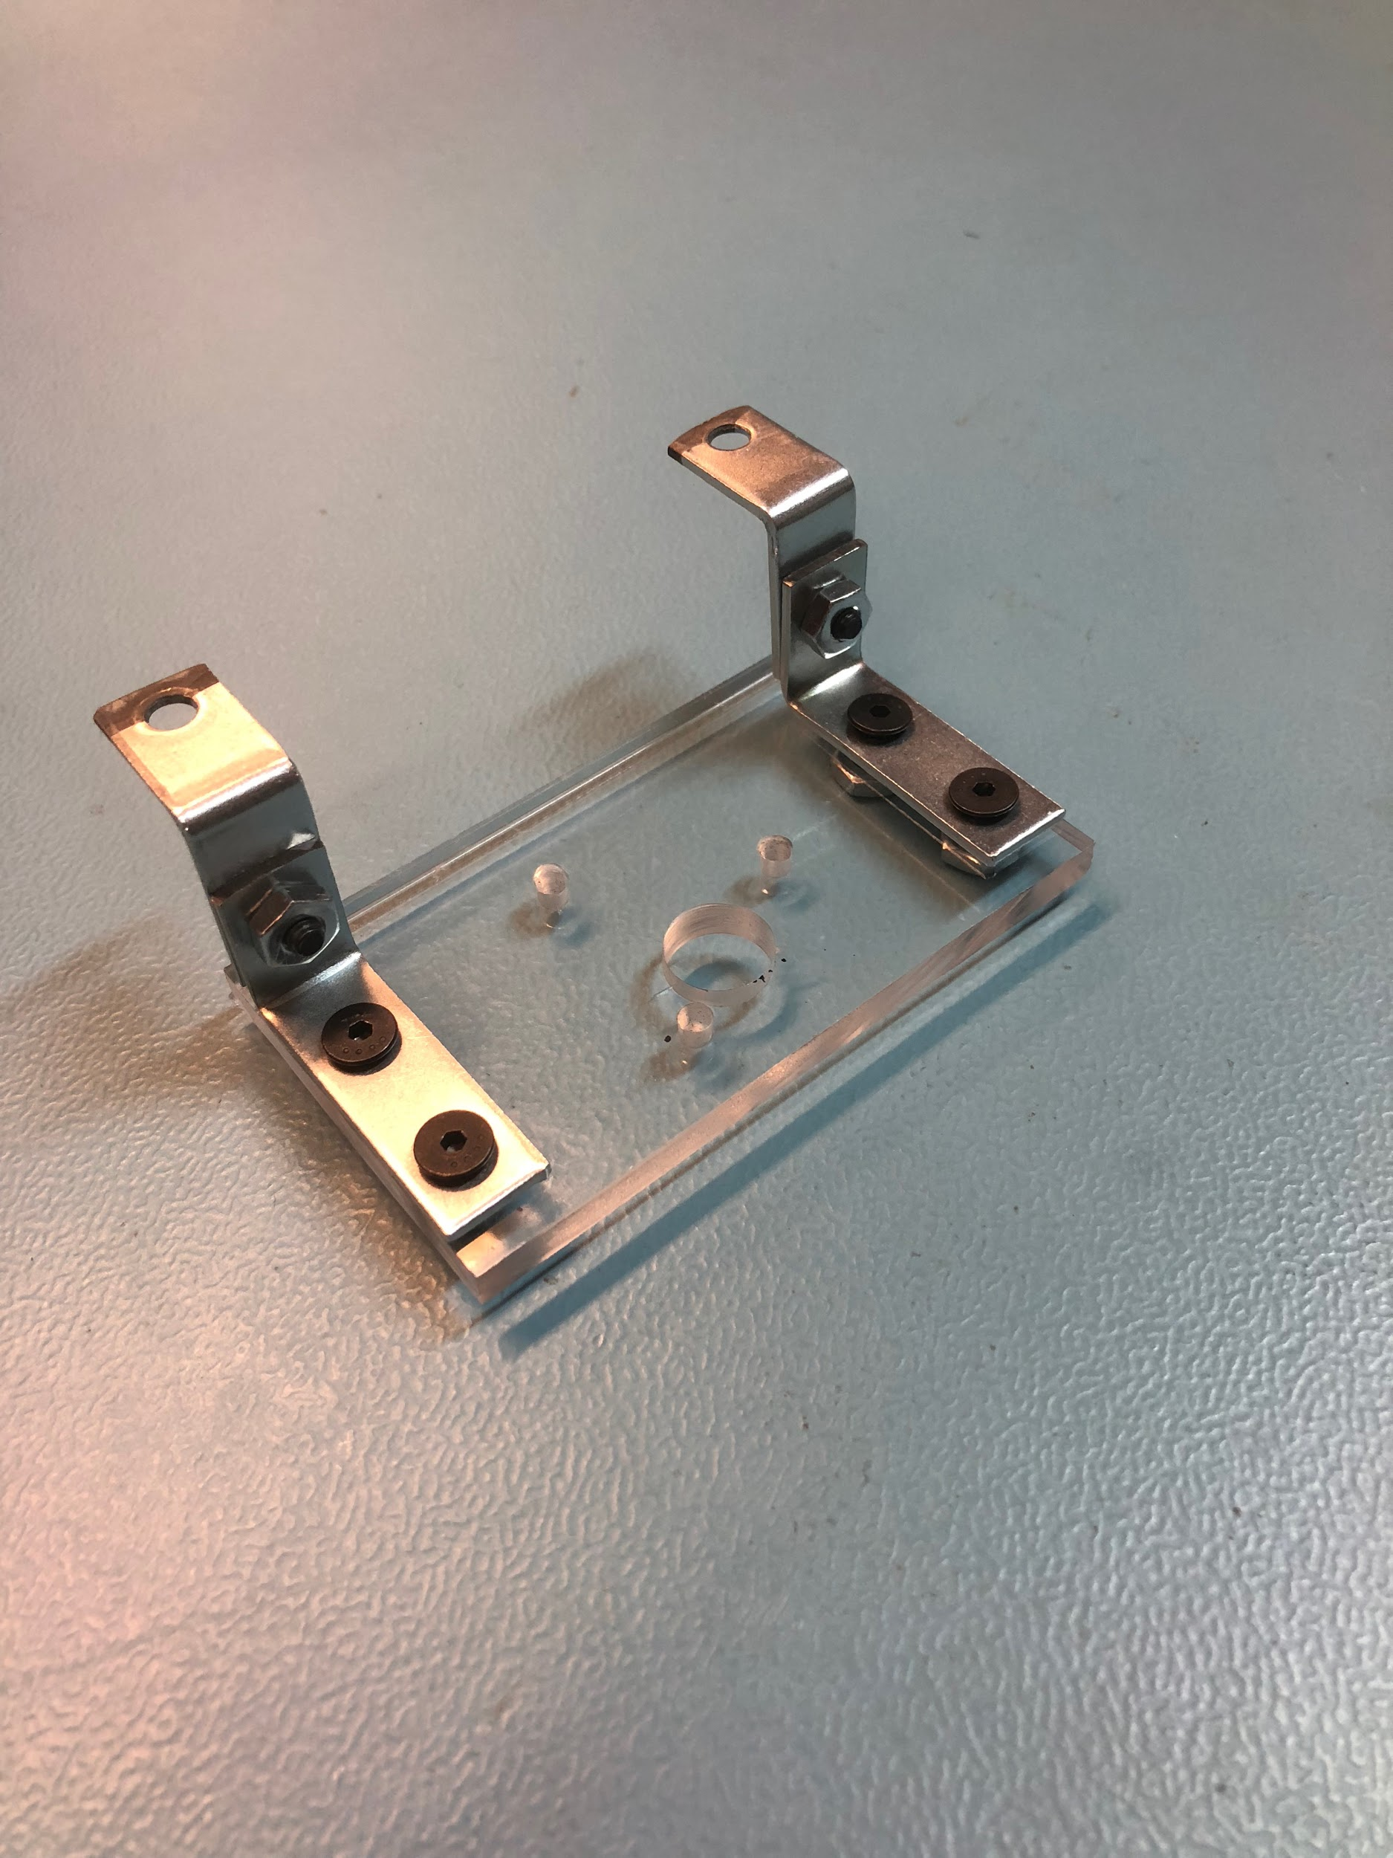

1. Screw the motor to the Motor Mounting Plate using M3 x 10mm screws

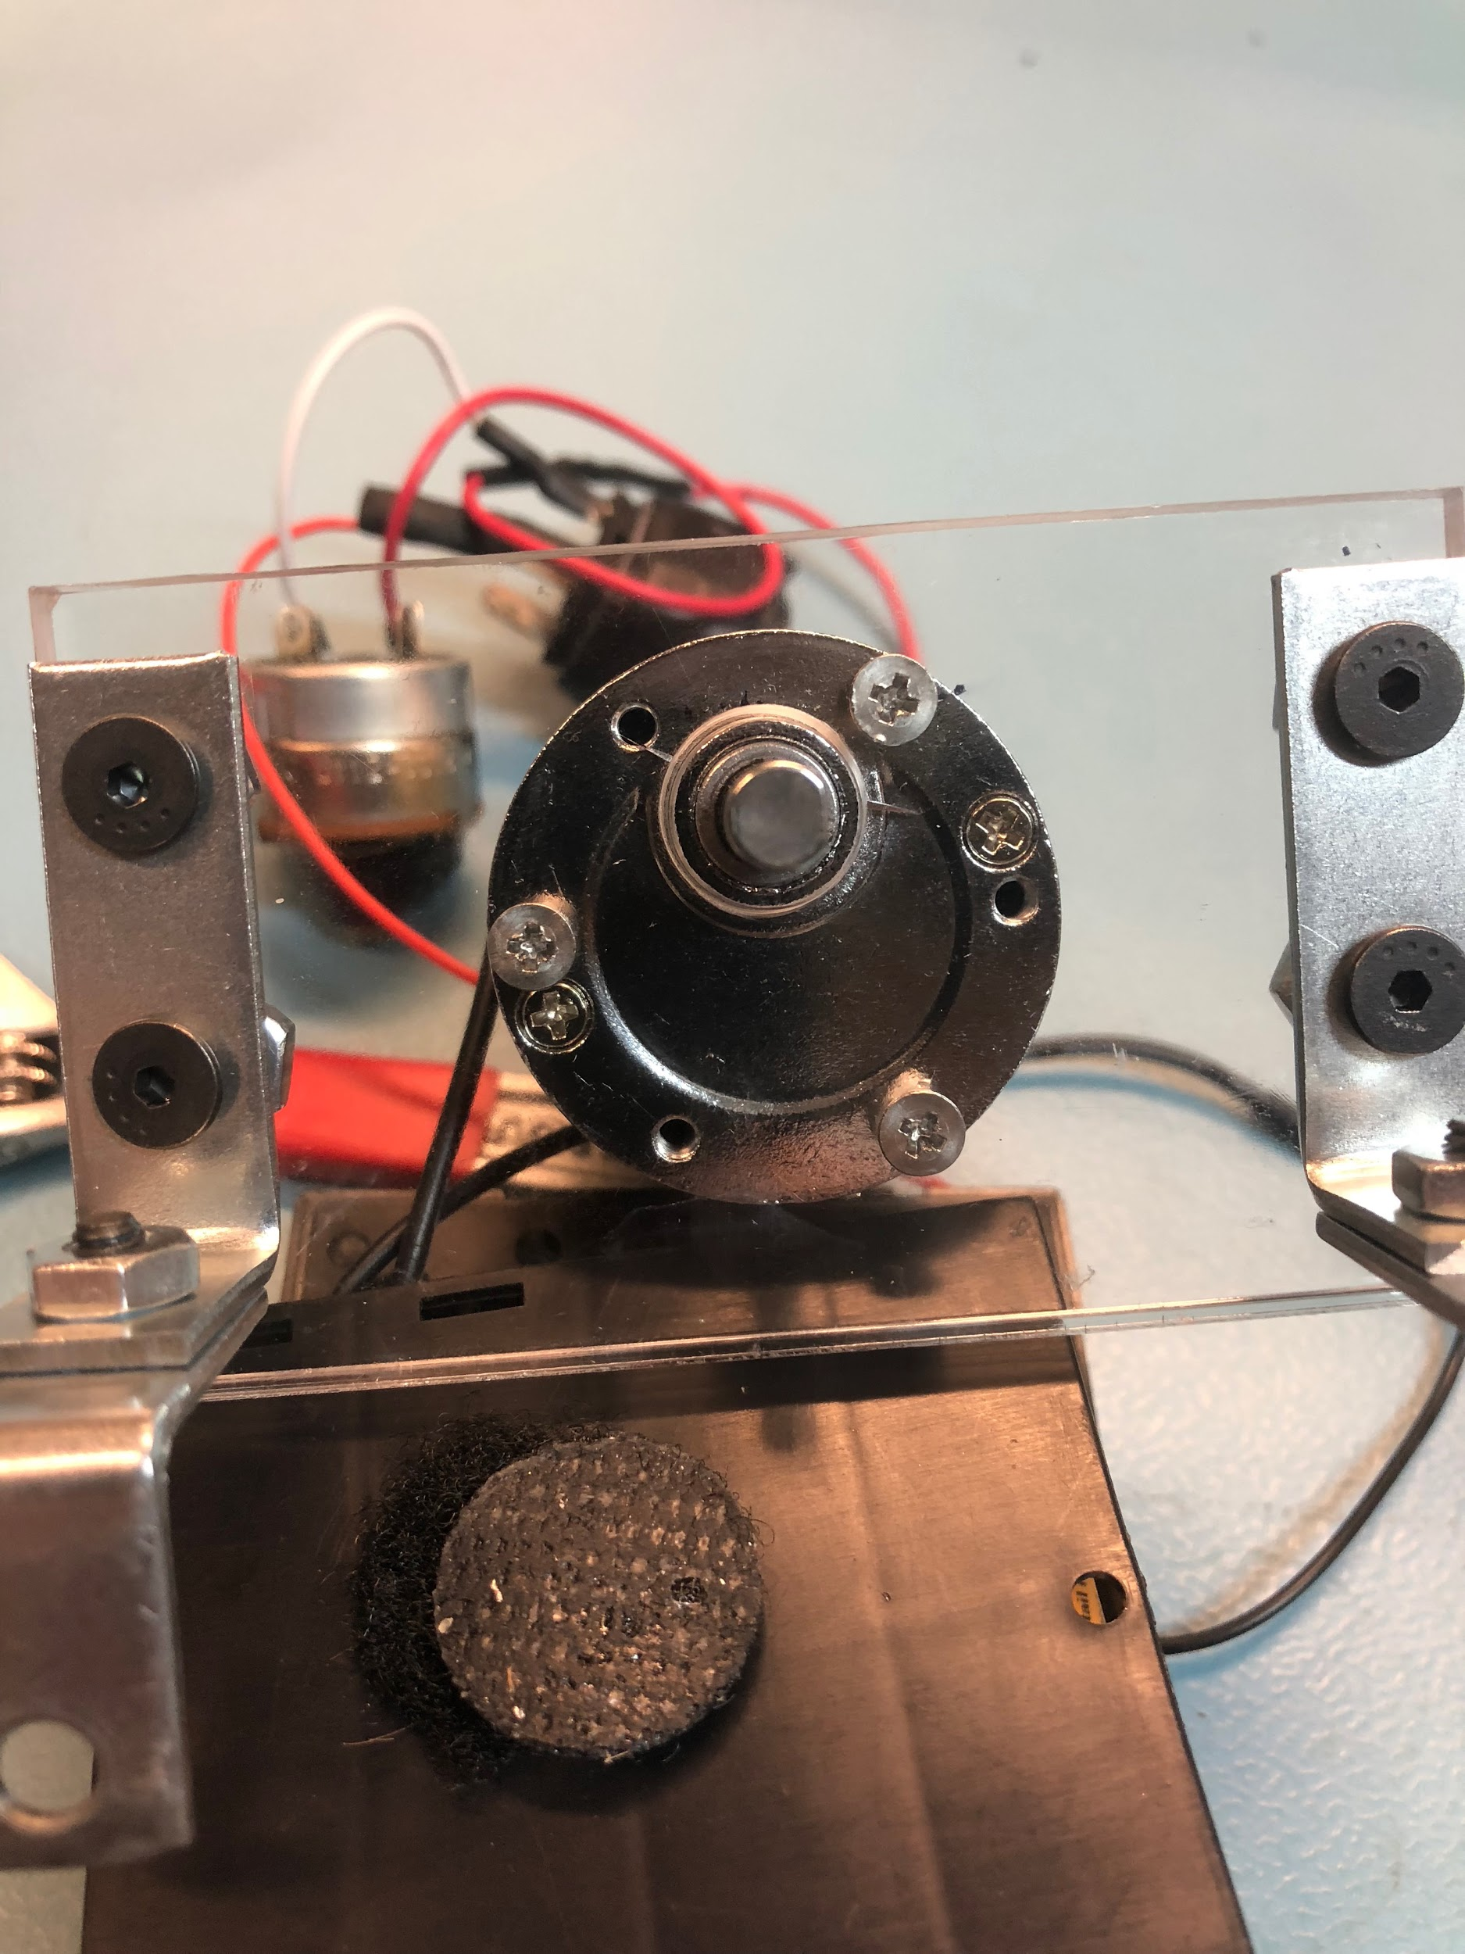

**Transmitter Box**

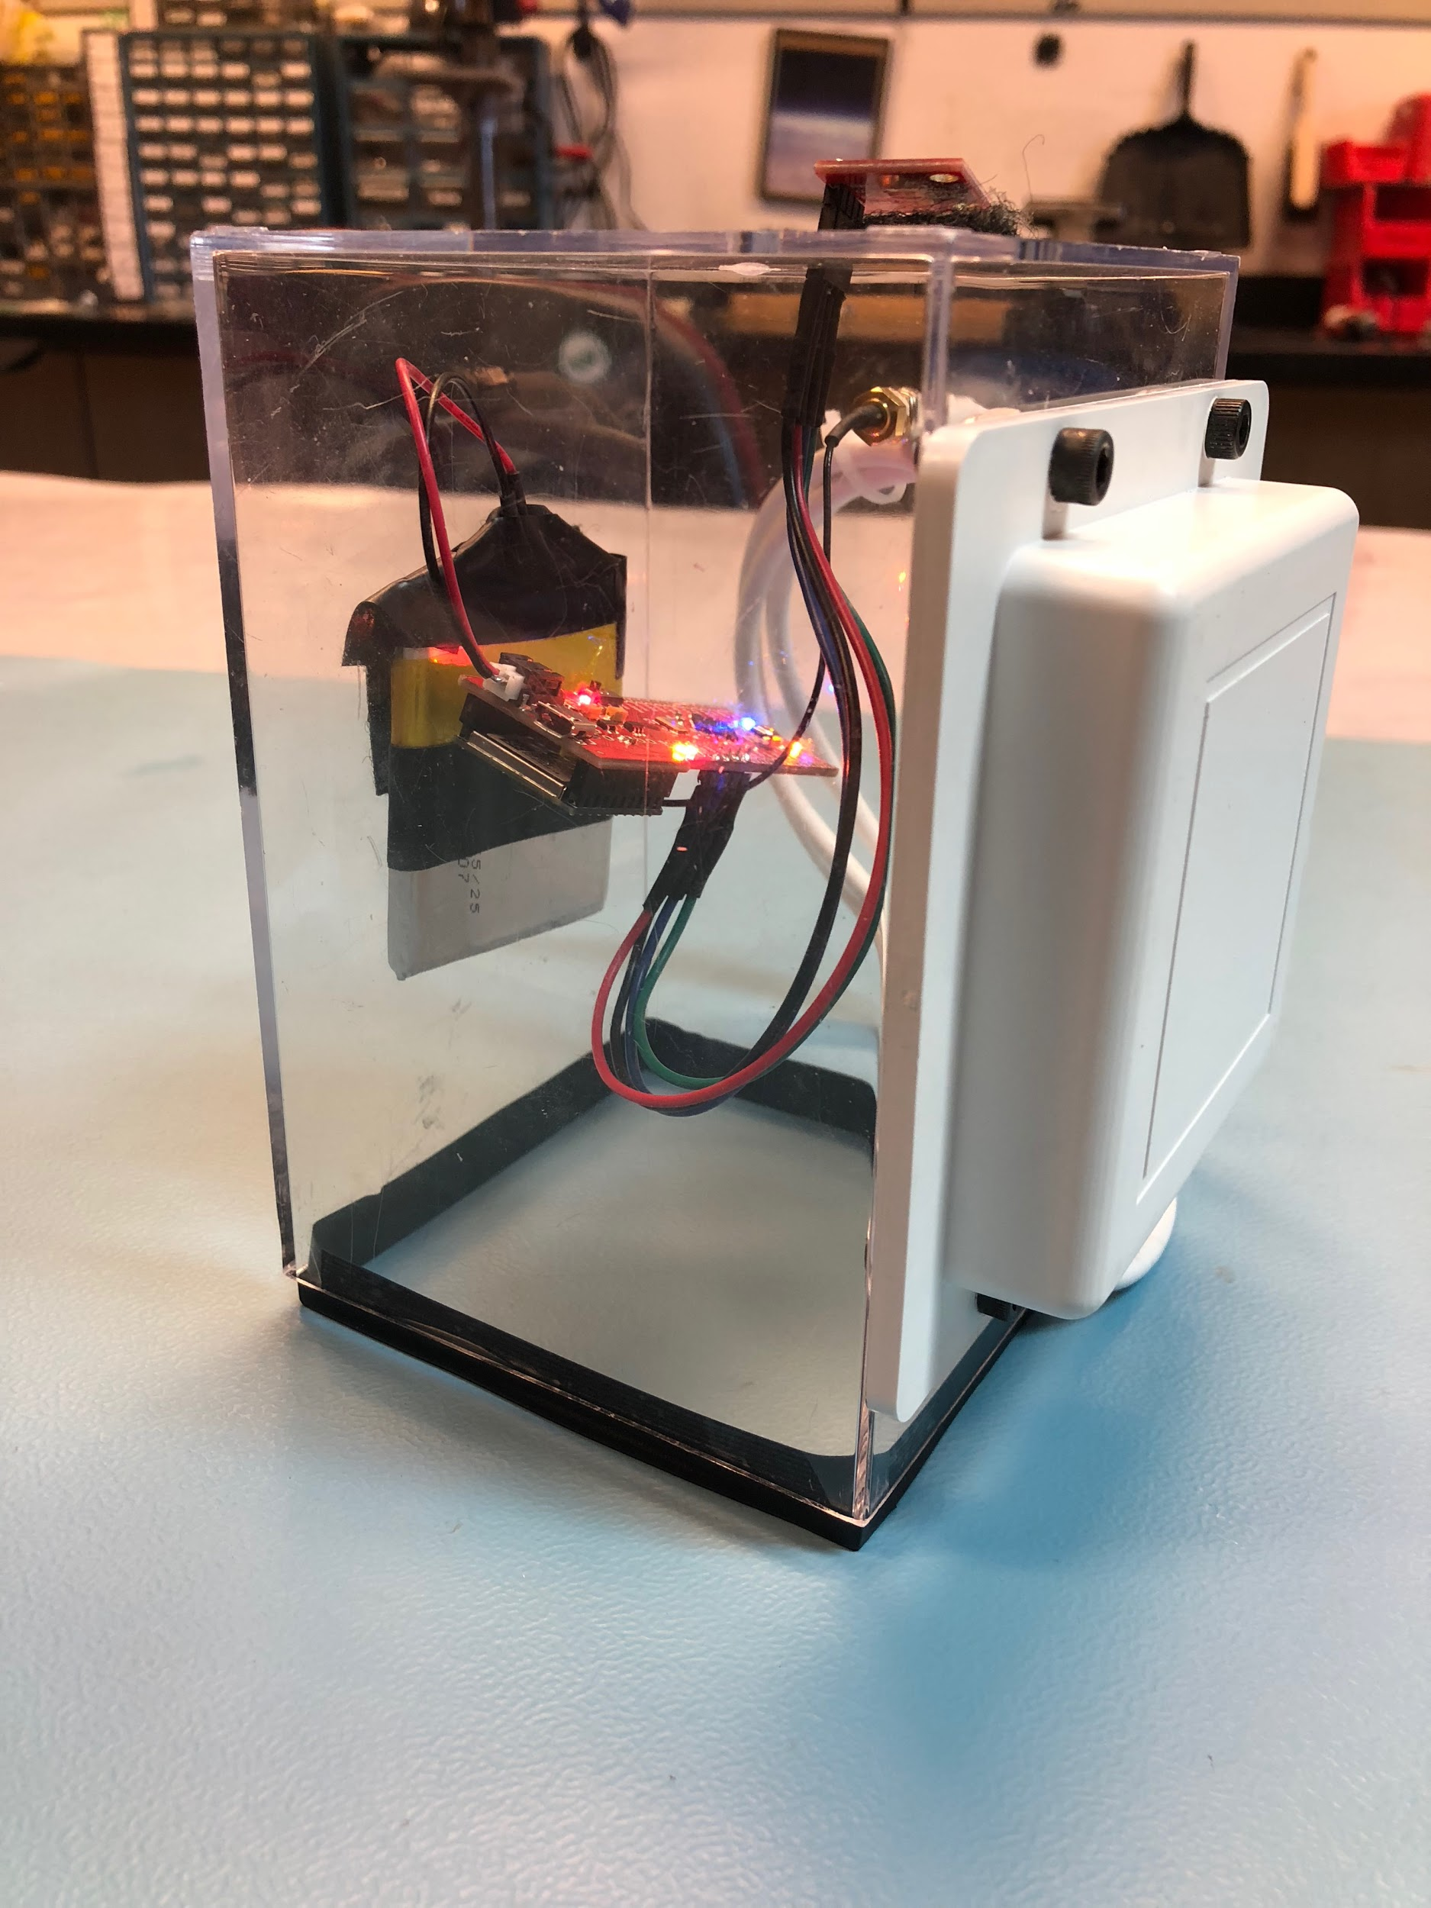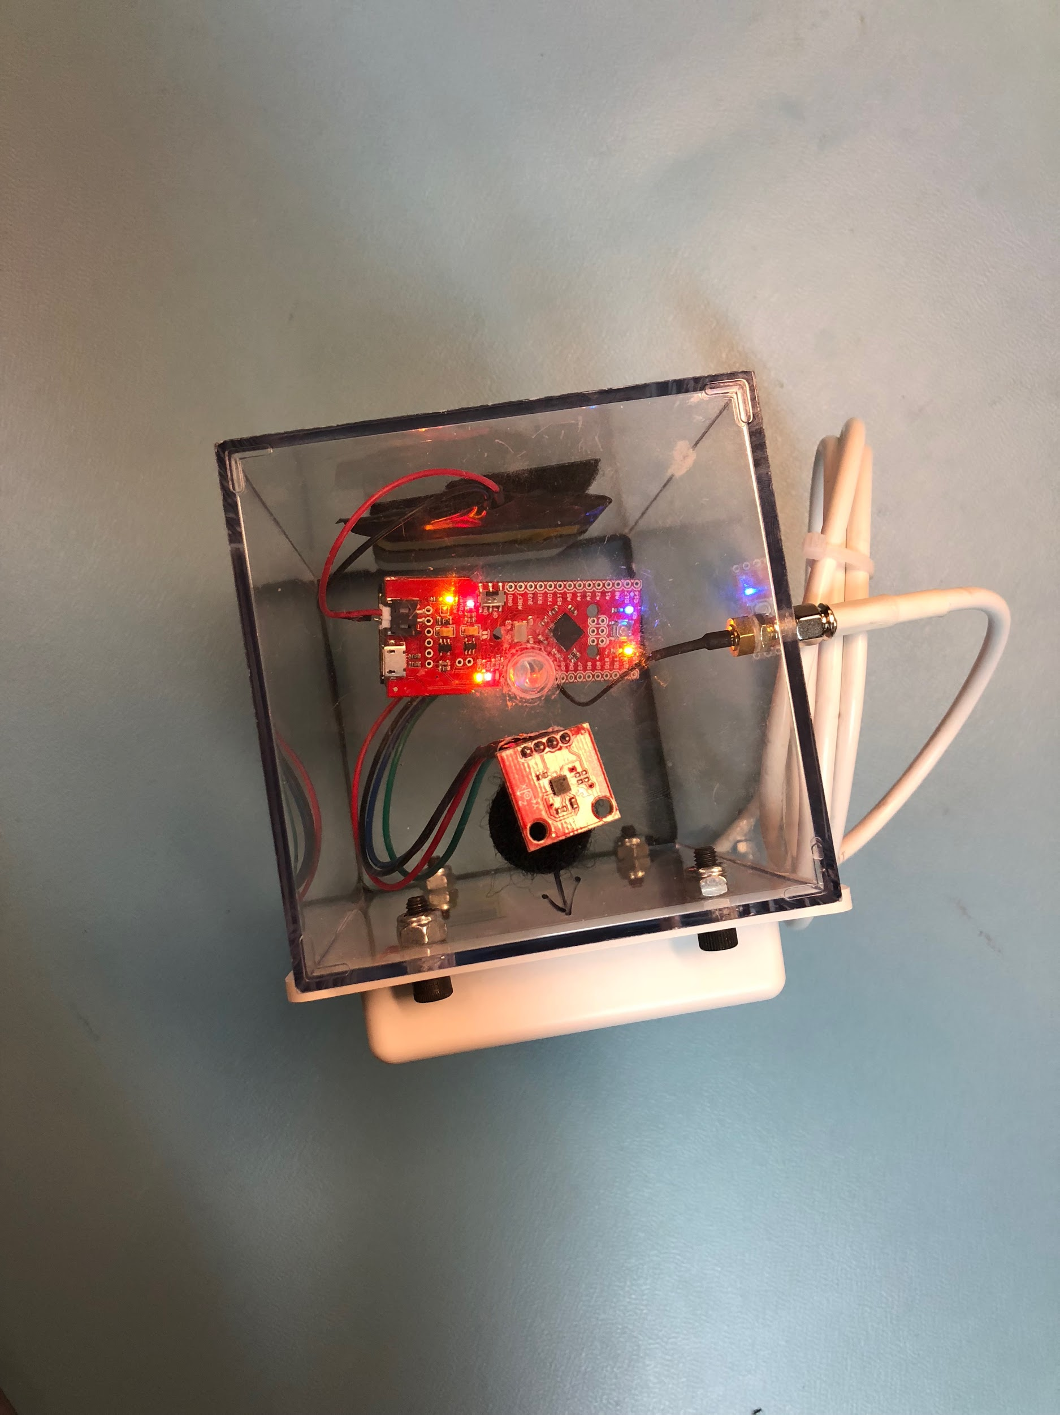

1. Place the Xbee on the Fio
2. On the top of the plastic box, dill a rectangular hole to fit the magnetometer and four holes on the side for the antenna

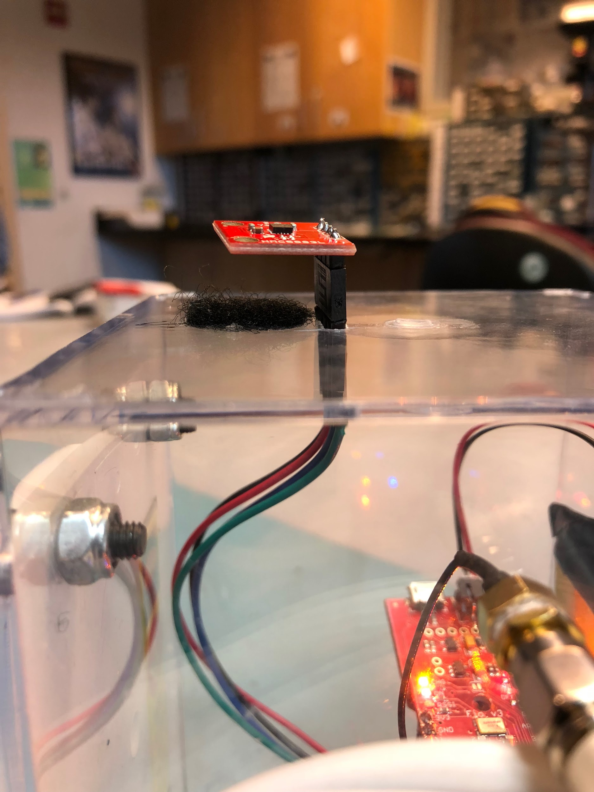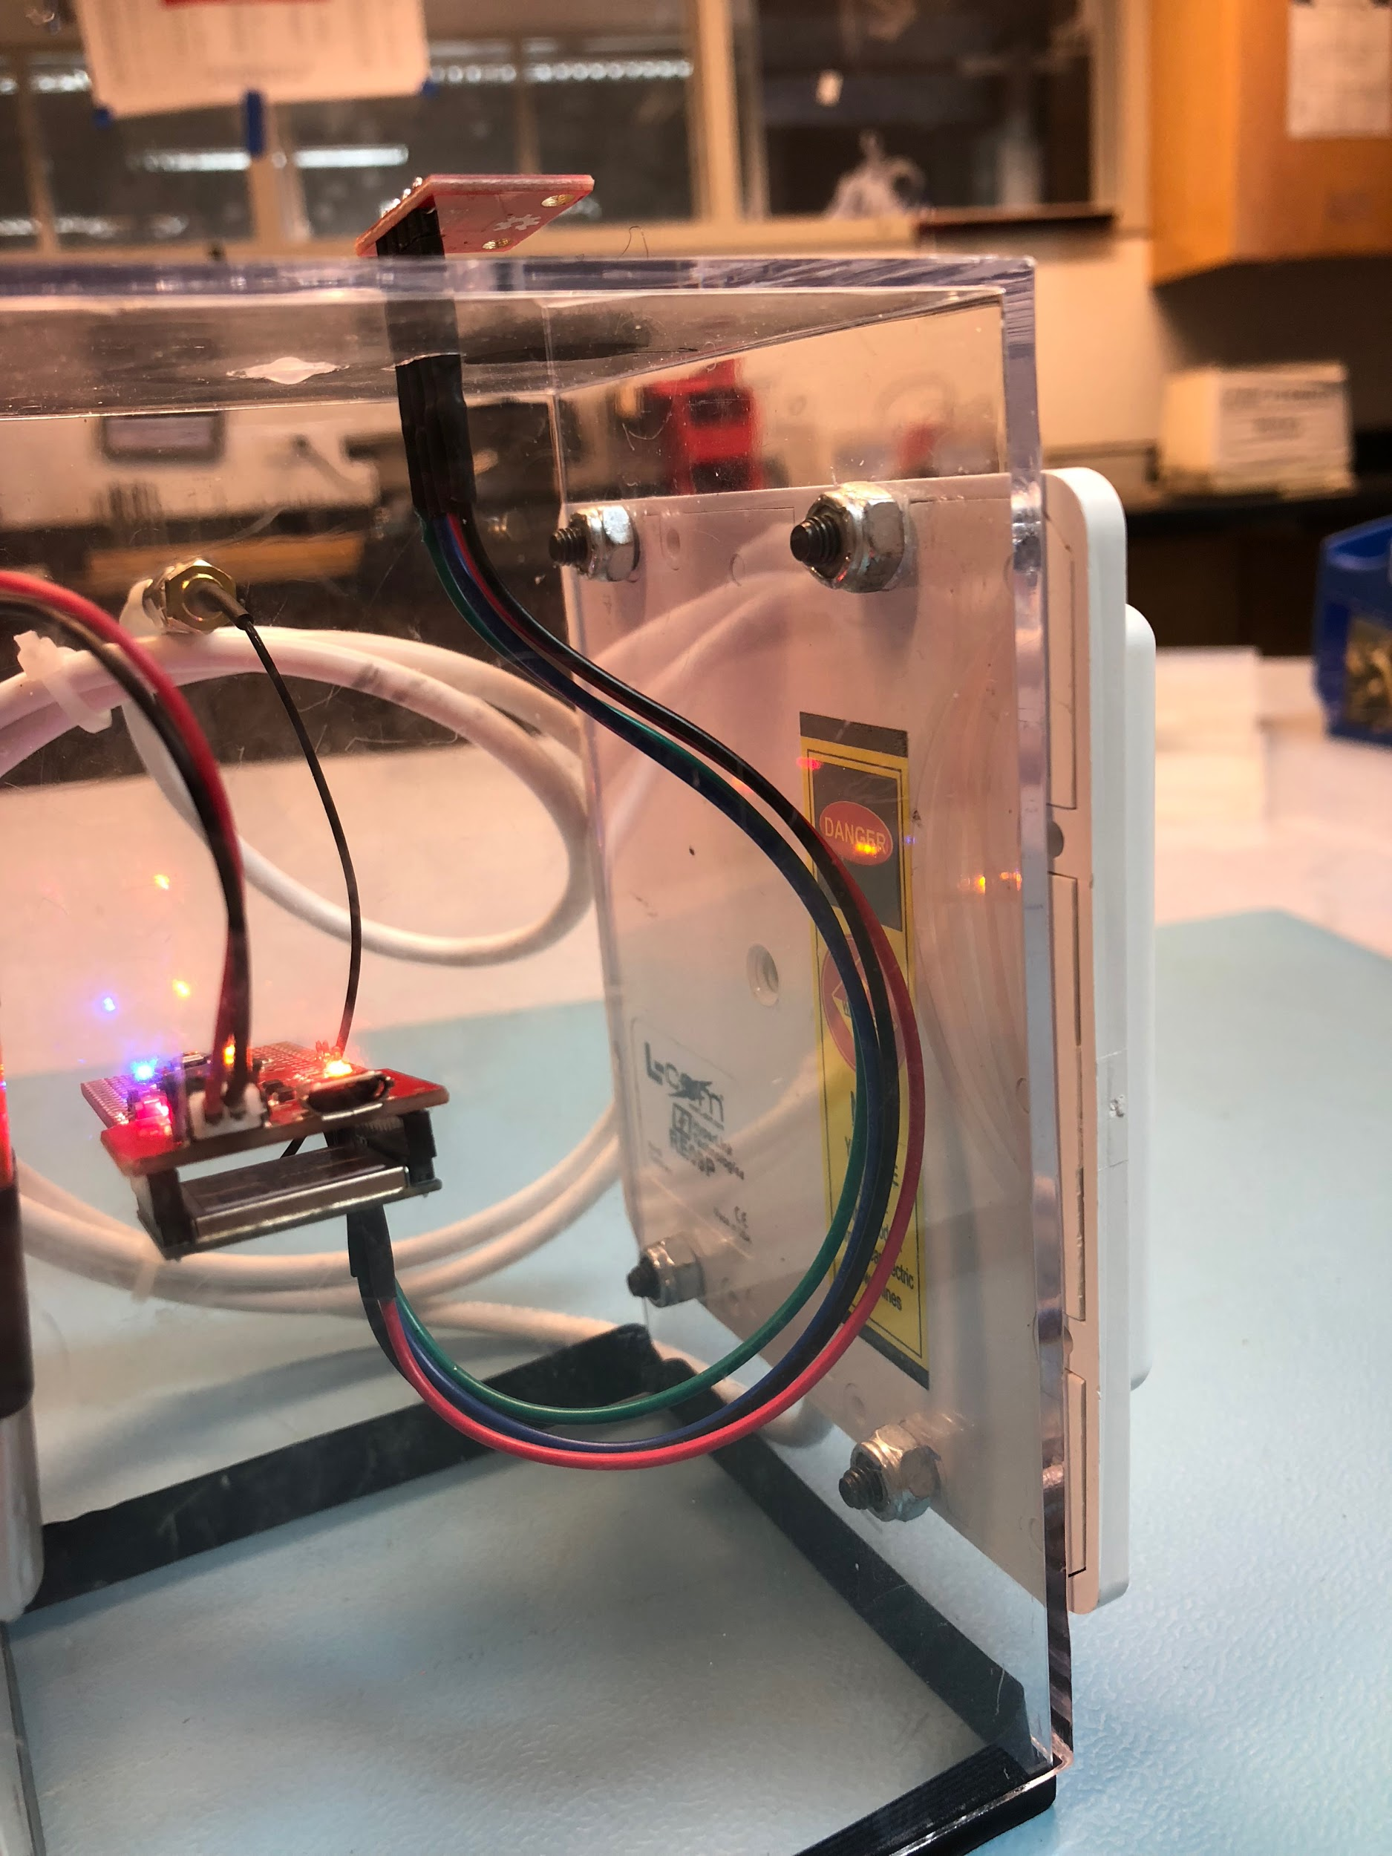

1. On a side of the plastic box that is adjacent to the antenna, drill a hole for the coaxial cable

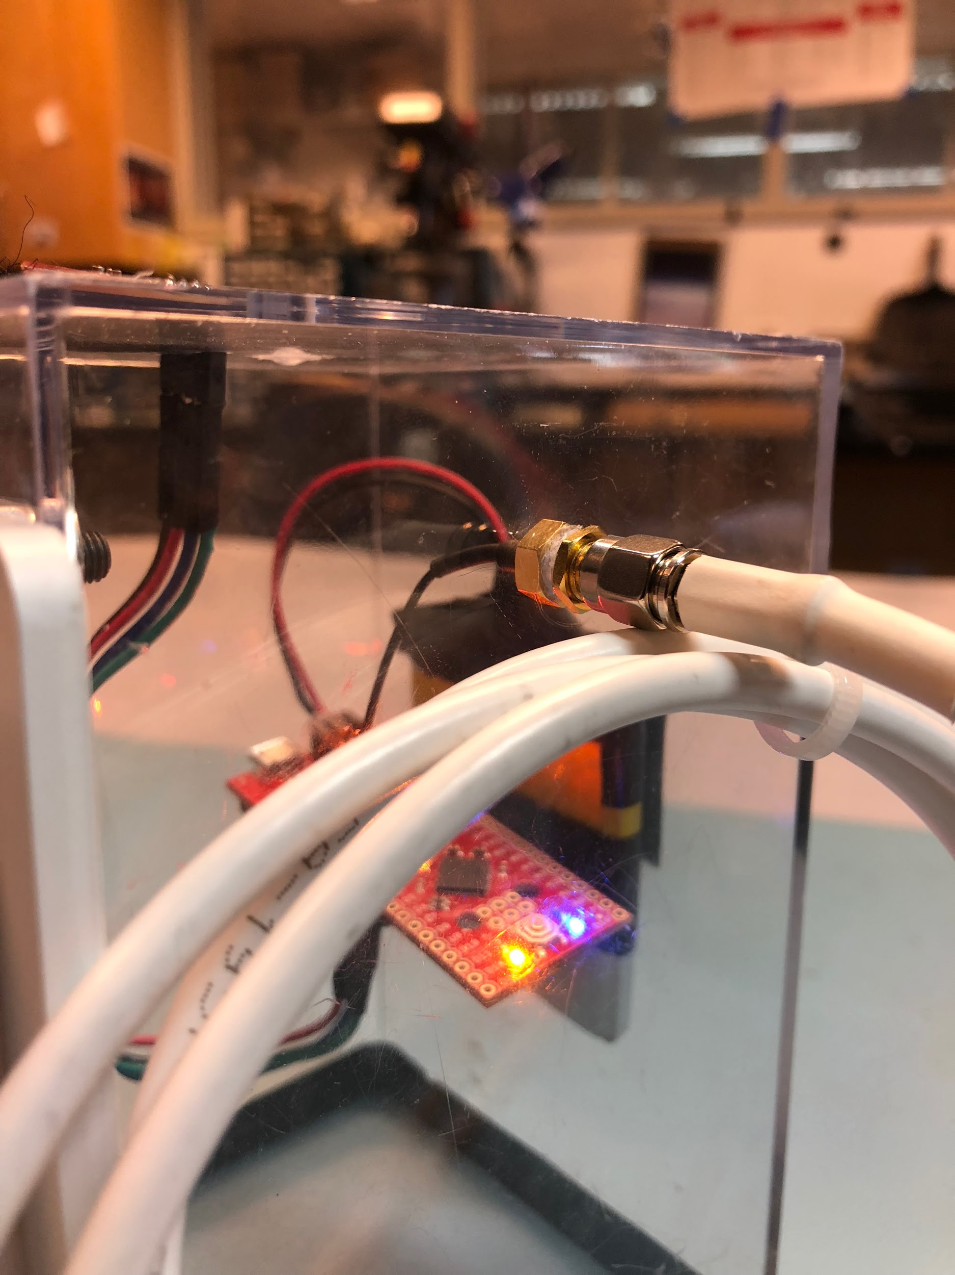

1. Attach the antenna to the XBEE
2. Solder the Fio to the magnetometer
   1. Note - there should be at least 6in of wire between them

**Base Box**

1. Begin by collecting and cutting top, sides, and bottom of the box out of a lightweight material (Acrylic recommended). Starting at top left of image: bottom, top, left, back right.

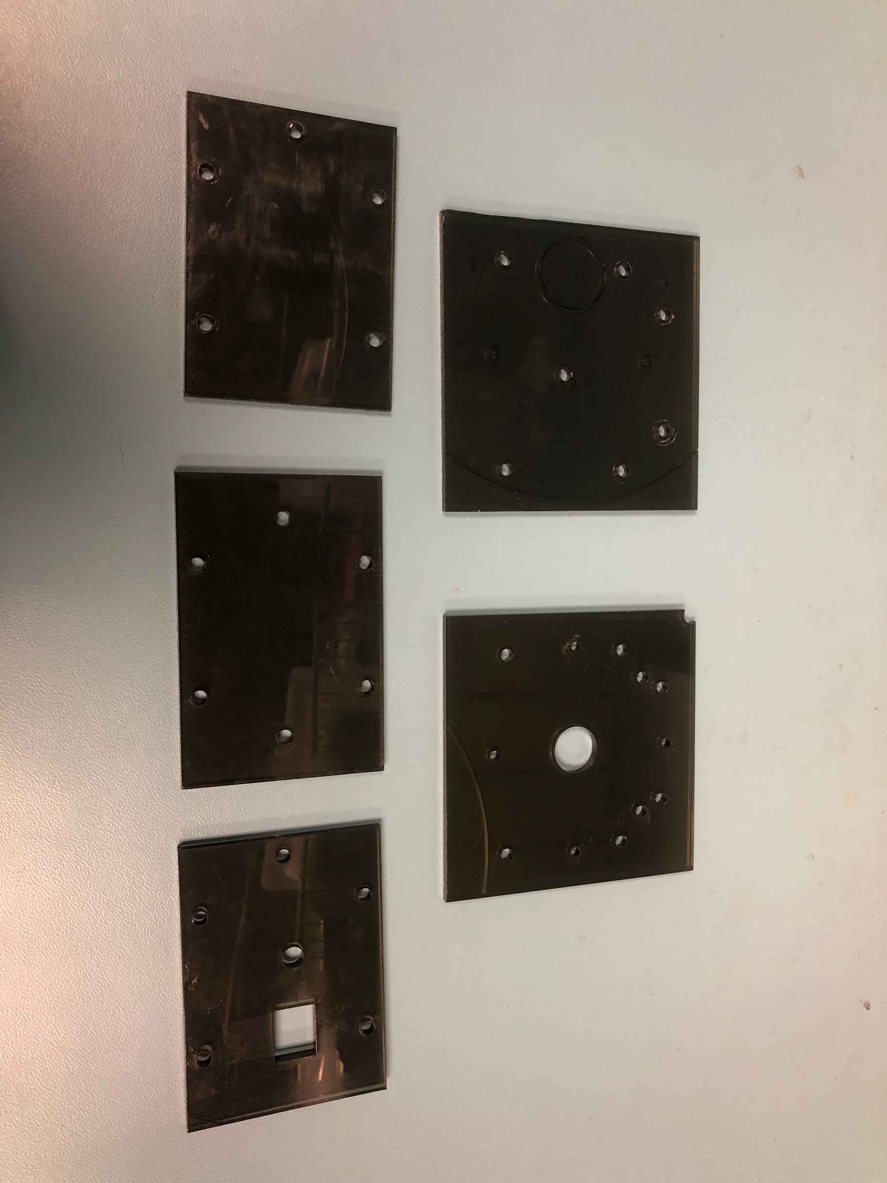

1. Attach the Left, Right, Back and Top sides of the base box together using 3/4 in. Zinc Plated Corner Braces 8-32 x 1/2in screws and 8-32 nuts. Leave the bottom off for now. The box is flipped upside down for assembly in the image below.

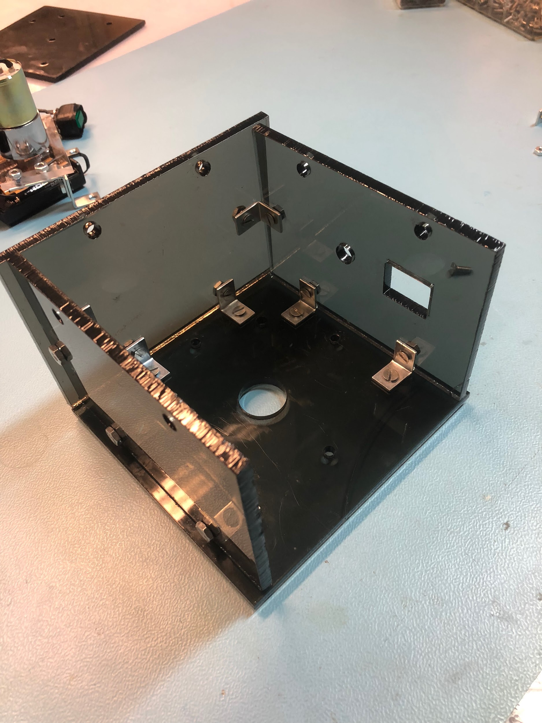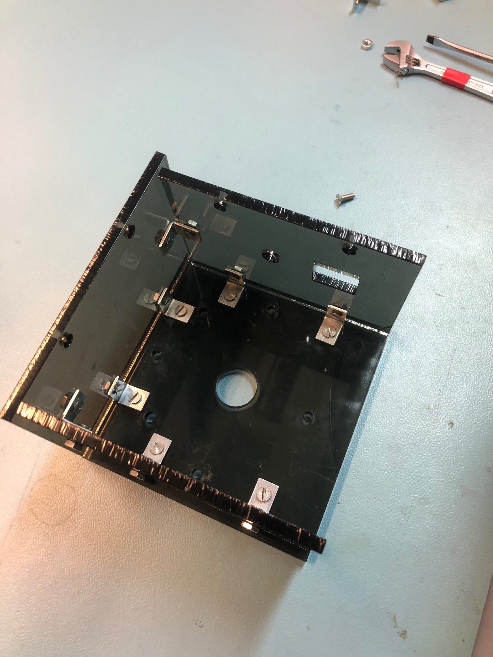

1. Attach the assembled Motor Mount to the top plate 8-32 x 1/2in screws and 8-32 nuts

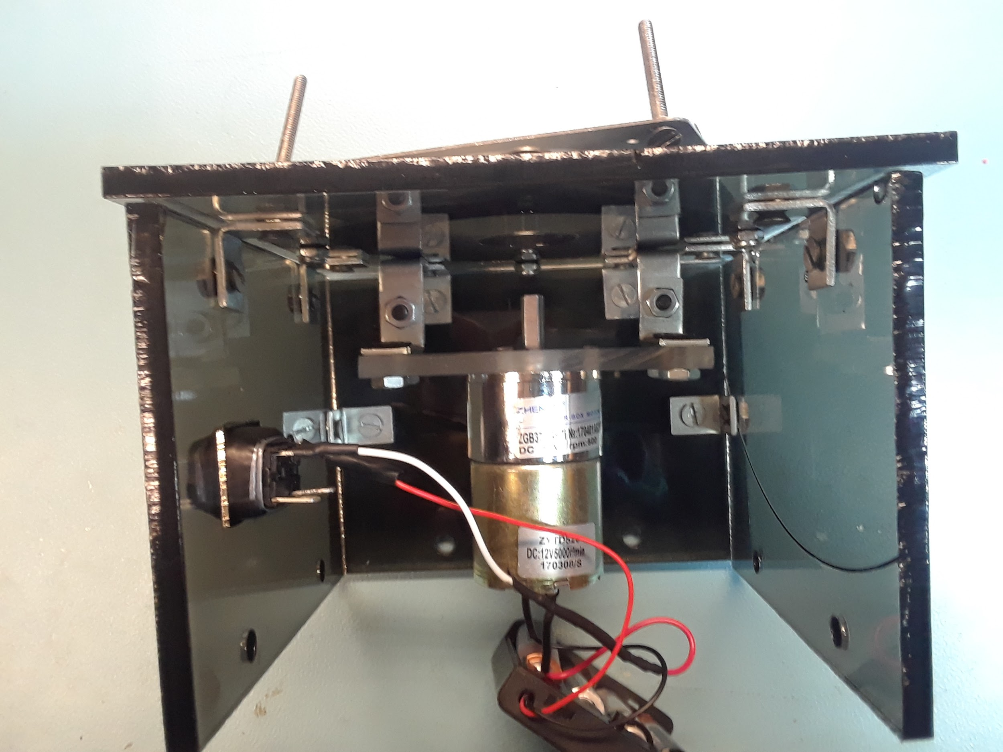

1. Take Tripod Mount and peel back rubber layer on the top. Remove screw, nuts and washer that came with beacon. Reattach rubber layer.

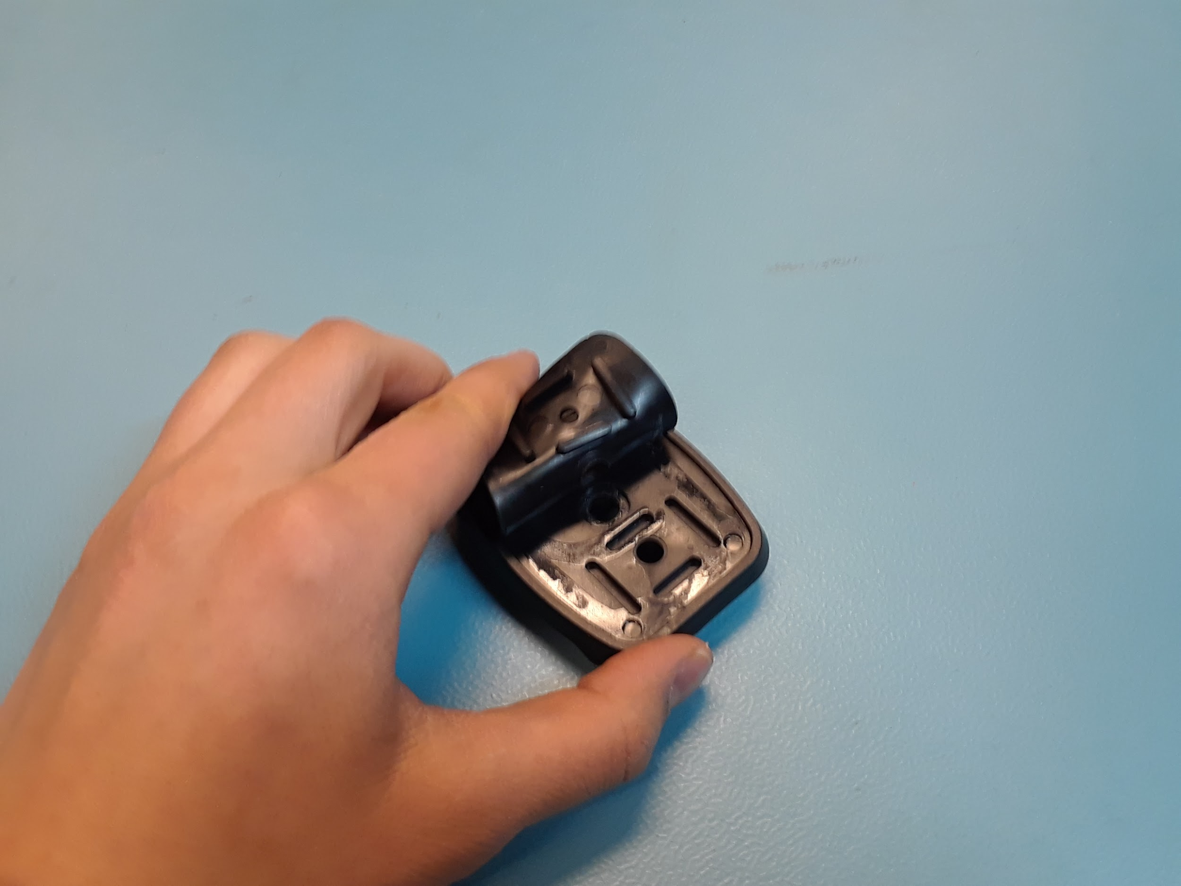

1. Attach a 10-32 x 3/4in screw through a 10-32-0.5 in diameter washer on the through the bottom of the Tripod Mount and through the center hole on the bottom of the Beacon Base, secure with a 10-32-1.25in washer and a 10-32 locking nut (order shown below)

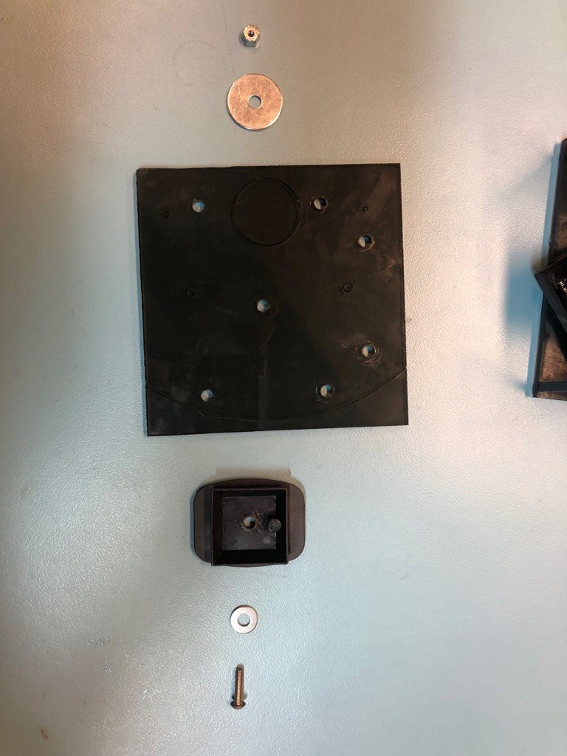

1. Place the 6-32 x 1.5in screws through the turntable
   1. Note, the Bearing is offset on either side, so make sure you put these screws in the side that aligns with the Rotation Plate. This should be the side with the holes furthest out.
   2. This is step is necessary because once the turntable is screwed onto the beacon base, there will not be the clearance for the screws to fit through the holes

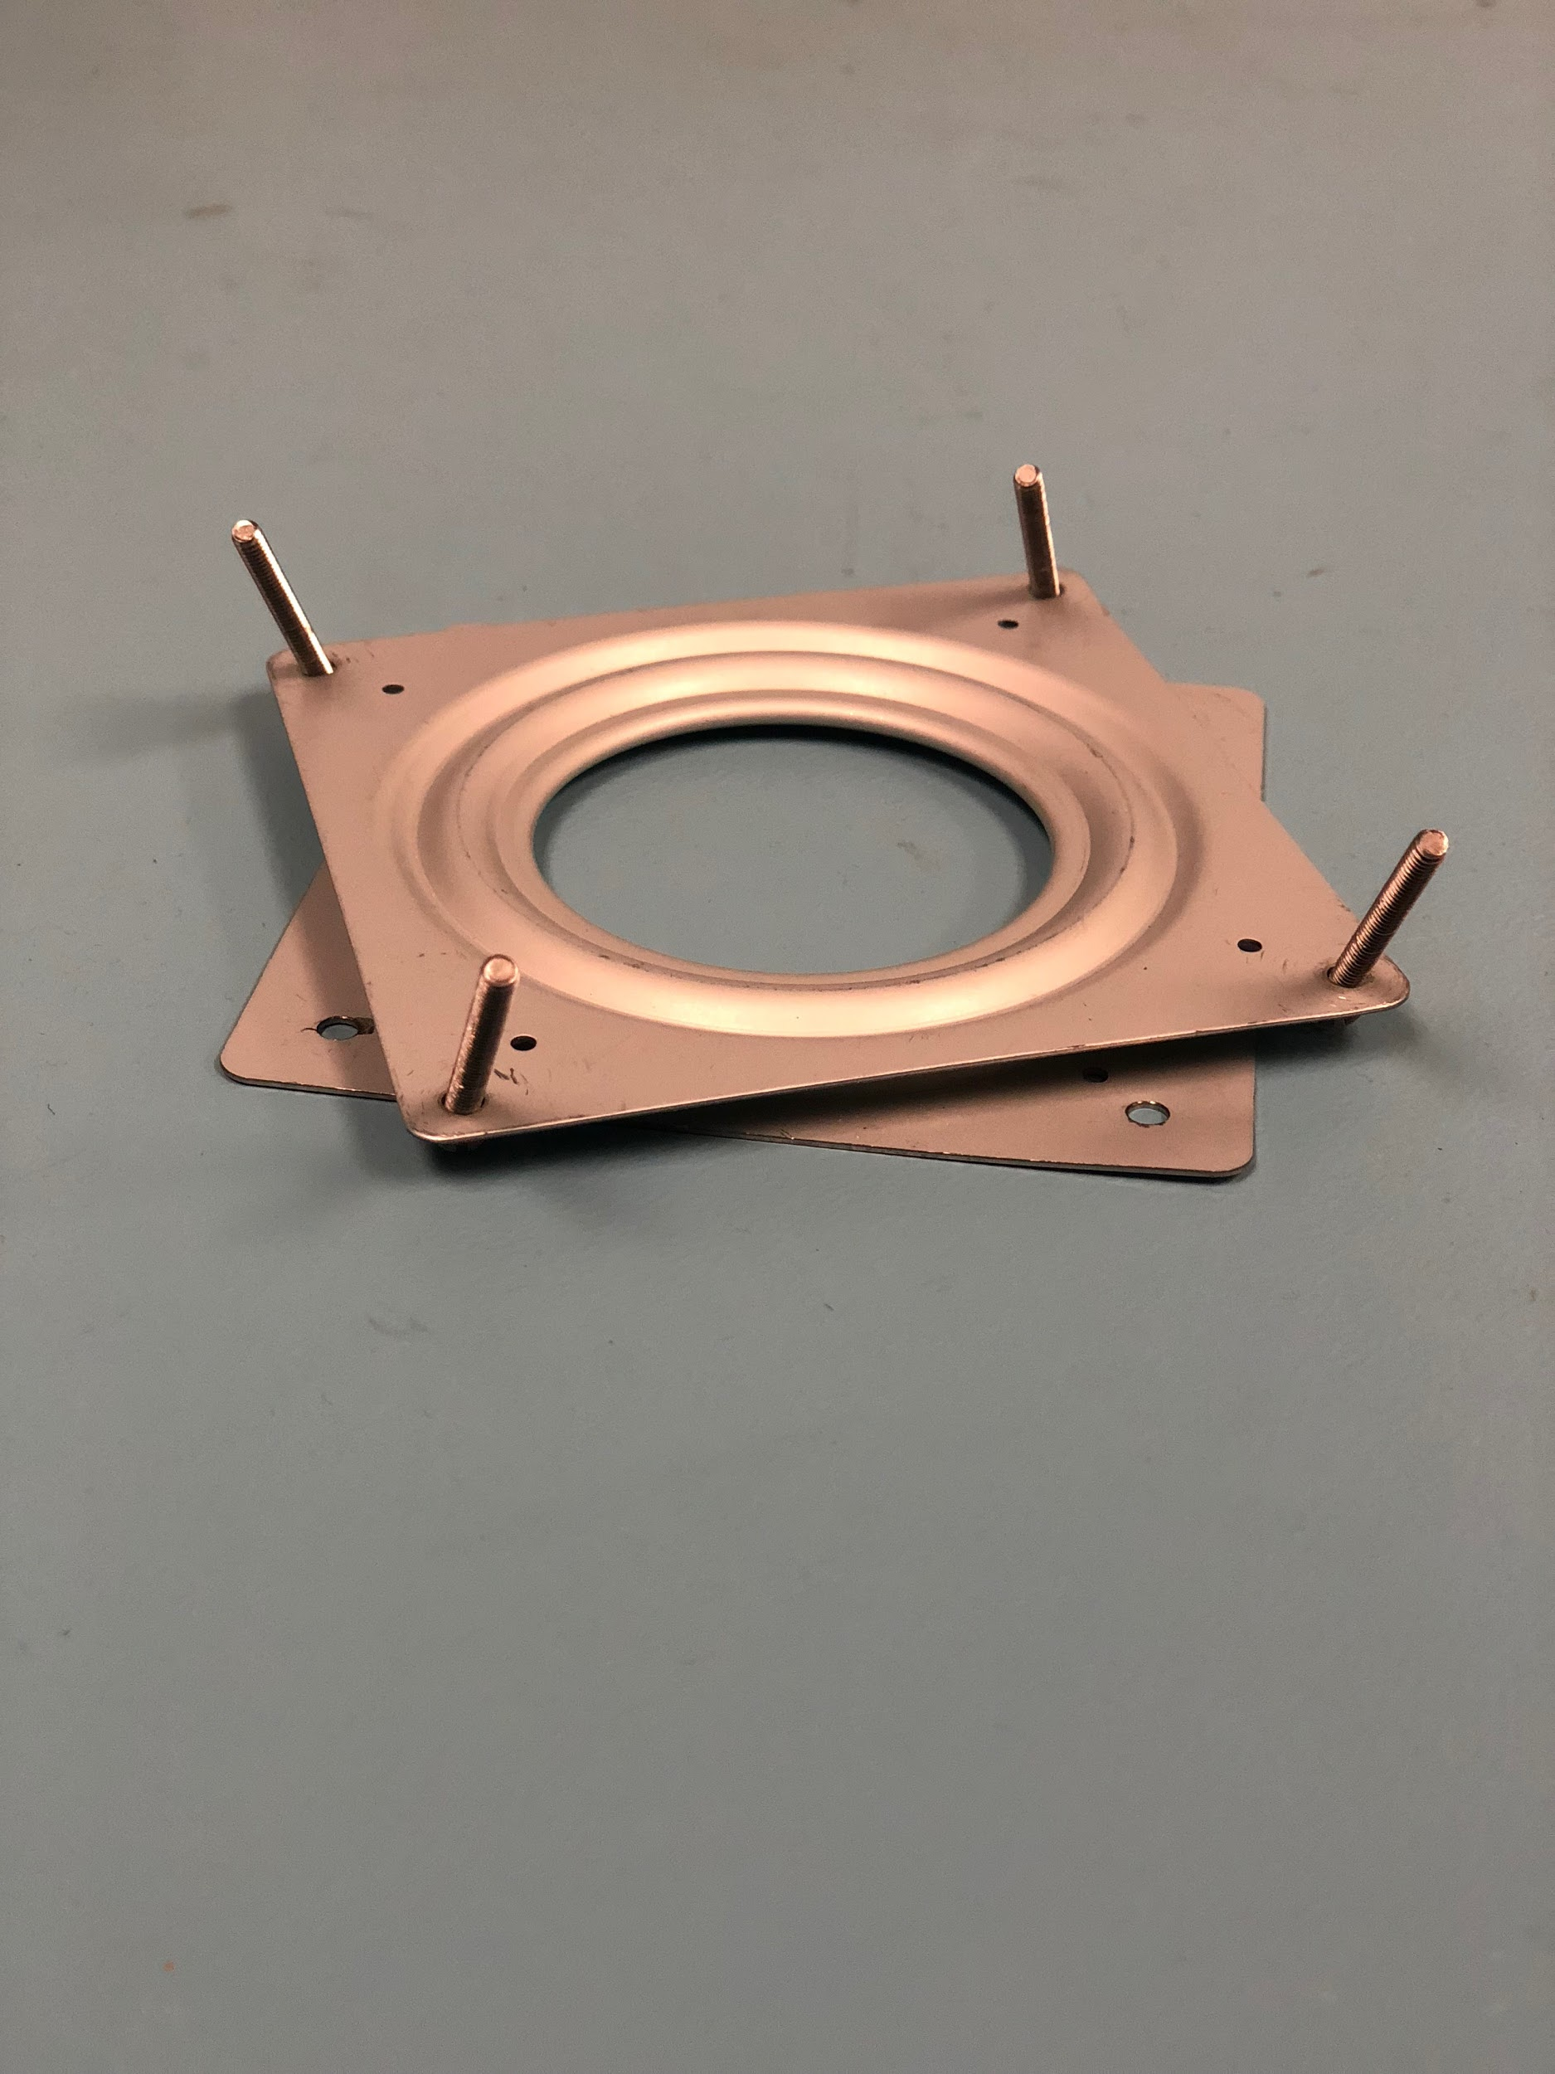

1. Screw in the Bearing to the top of the base box using 4 6-32 x 1/2in screws and a 6-32 in locking nut
   1. Note again, the turntable is offset on either side, so if the holes are not lining up, try the other side of the Bearing.

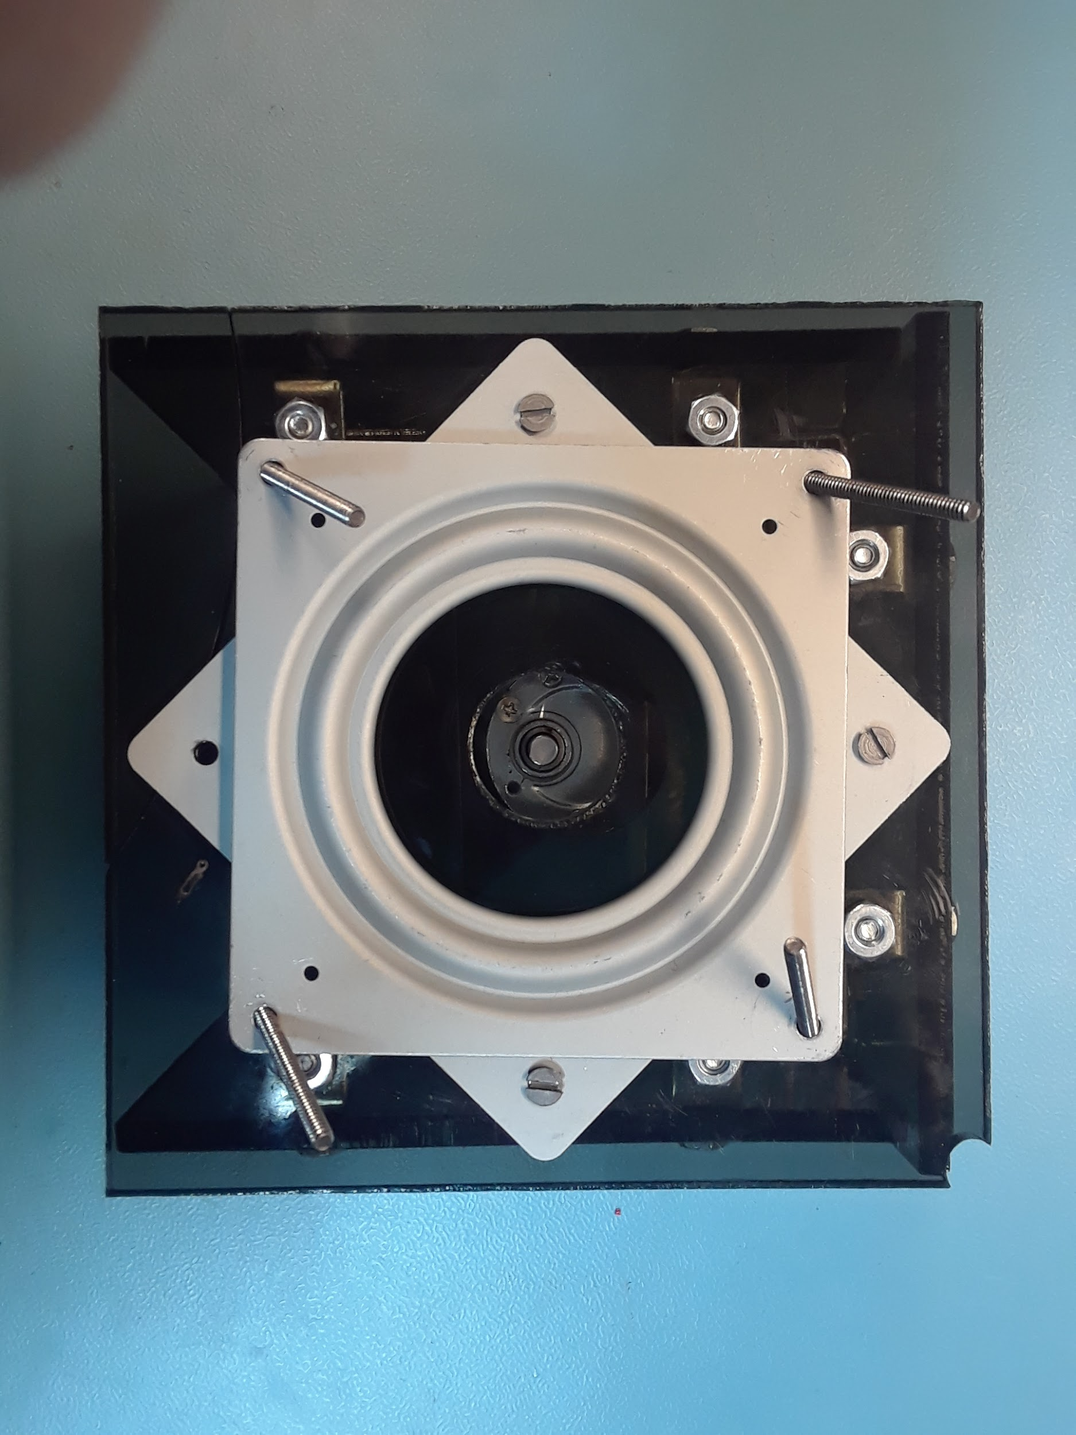

1. Attach the bottom of the beacon base using 3/4 in. Zinc Plated Corner Braces 8-32 x 1/2in screws and 8-32 nuts. Ensure the side with the Tripod Mount is on the outside.

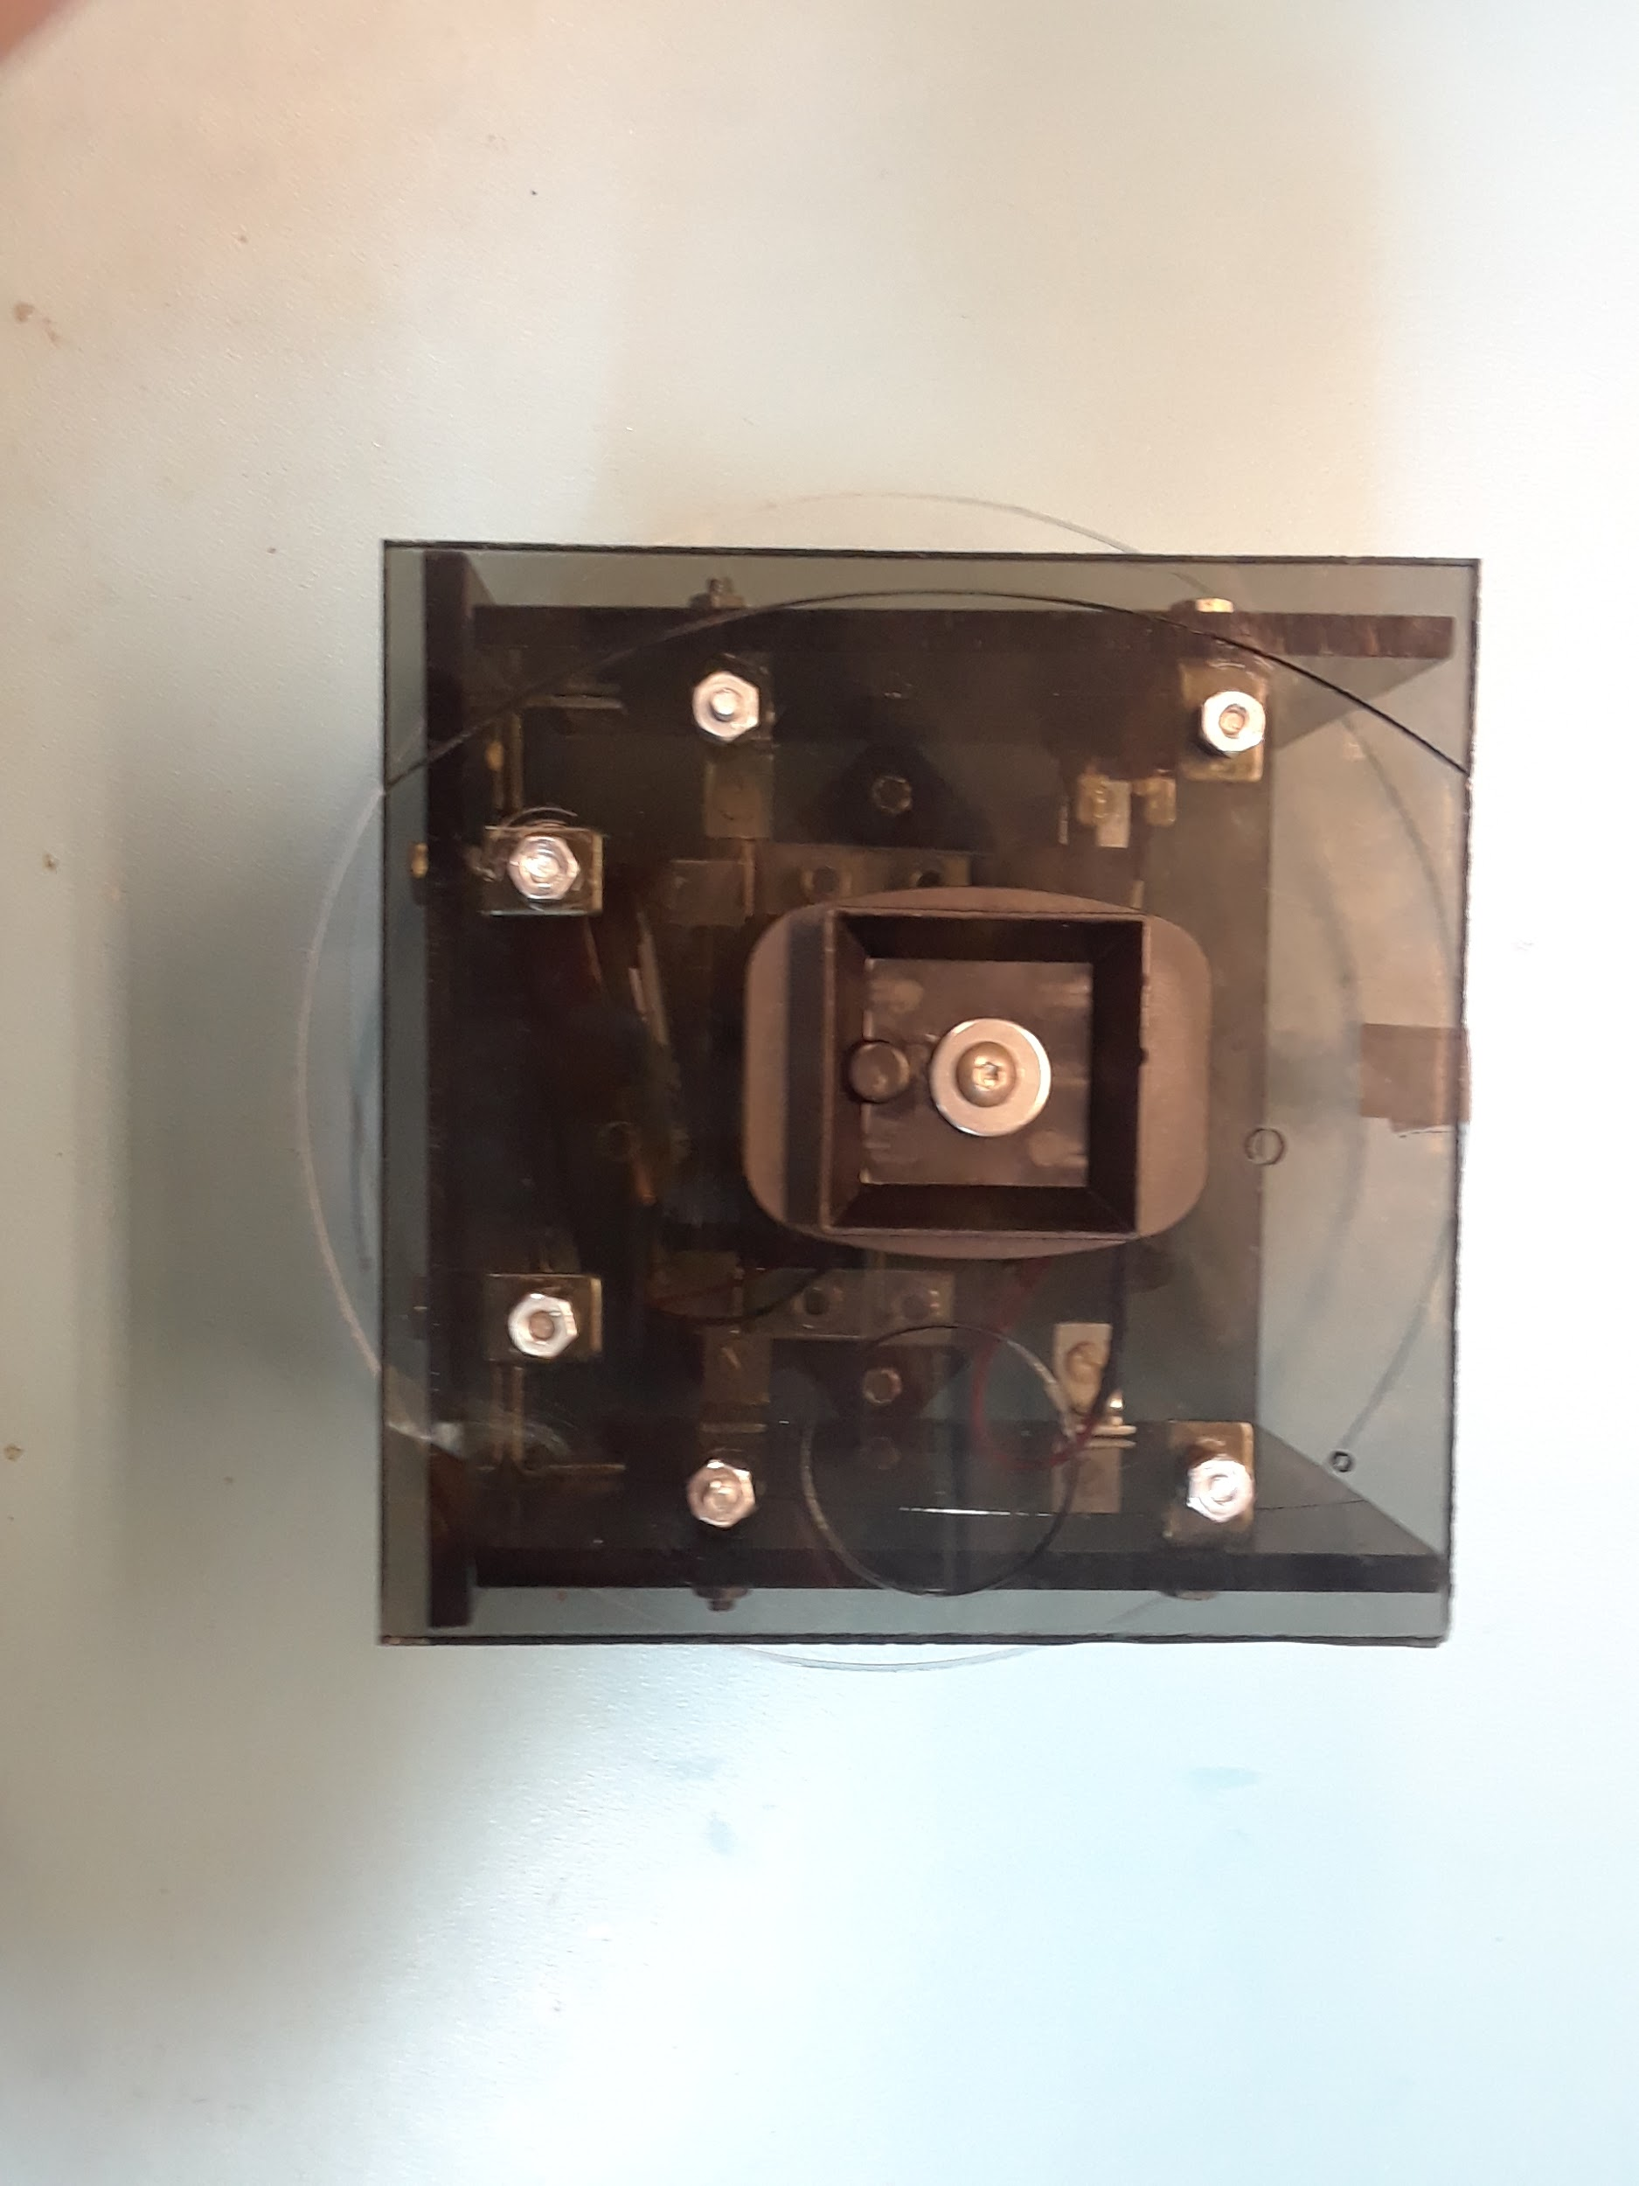

1. Place the Rotation Plate on the turntable, aligning it with the long screws. Secure with 6-32 nuts
   1. Make sure motor is properly aligned with Beacon Motor Attachment

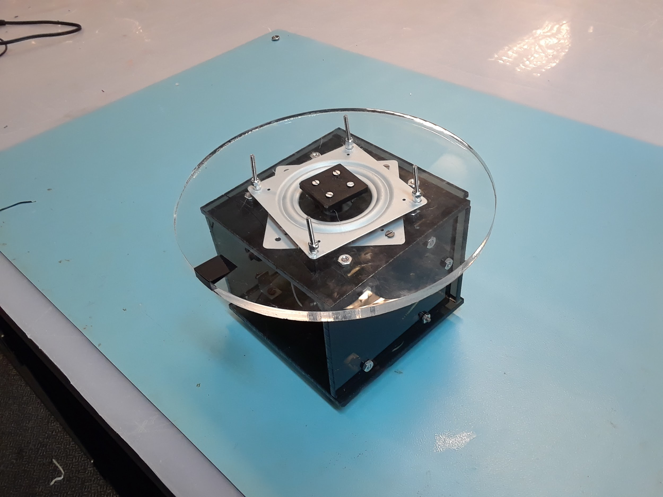

1. Place the transmitter box on top of the Rotation Plate

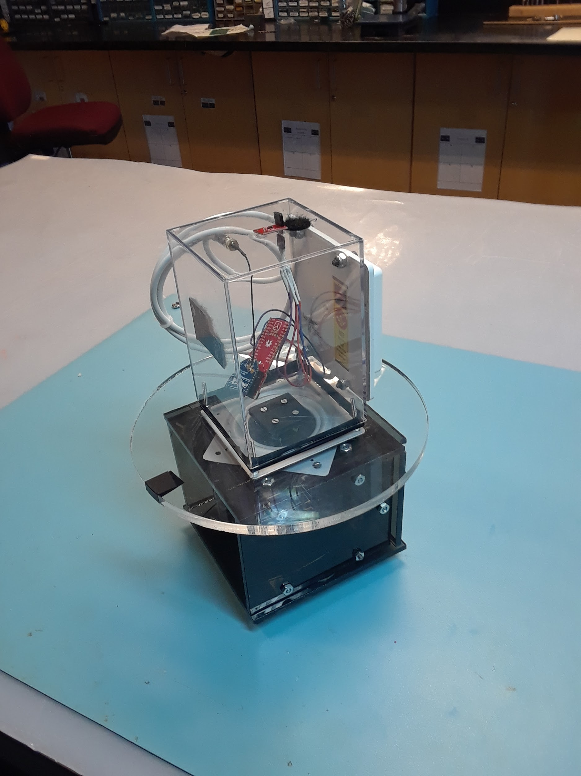

**Final Assembly**

1. Make sure there are new batteries
2. Place beacon on tripod and make sure it is securely attached
3. Turn on switch. You may have to give the rotation plate an initial push to start it.

**Troubleshooting**

* The device should be rotating at about 1.6 RPS. If not:
  + - Change batteries or change motor. Check/ vary resistor value or number of batteries as your system might vary due to materials/ tolerances
* Plastic disk not rotating evenly
  + - Double check that the motor is in the direct middle of the turntable and the acrylic
* Motor giving out
  + - Recheck all connections with a multimeter. if it does not work replace the motor.